**2019**

**Rutherford Regional Health System**

**Community Health Needs Assessment**

**Rutherford County, North Carolina**

*(This document will be created in InDesign with graphic design and* ***community photos*** *throughout. After edits by RRHS, the InDesign document will be prepared in the LifePoint template.)*

Paper copies of this document may be obtained at Rutherford Regional Health System 288 S. Ridgecrest Street, Rutherfordton, NC 28139 or by phone (828) 286-5000. This document is also available electronically via the hospital website: [www.myrutherfordregional.com](http://www.myrutherfordregional.com).

Table of Contents

Process—Creating a culture of health in the community 5

2019 Community Health Needs Assessment 6

Participants 6

Project Purpose and Goals 6

Community Input and Collaboration 7

Data Collection and Timeline 8

Input of Public Health Officials 9

Input of Medically Underserved, Low-Income and Minority Populations 10

Community Selected for Assessment 10

Elements of a Healthy Community 11

Key Findings of the Community Health Assessment 12

Results 12

Information Gaps and Limitations 12

Processes and Methods 12

Core Dataset Collection 12

Demographics of the Community 14

Health Status Data Summary 16

Social and Economic Factors 16

Income & Poverty 16

Employment 17

Education 17

Community Safety 17

Housing 18

Family & Social Support 19

Health Data Findings Summary 20

Mortality 20

County Health Rankings – Outcomes and Factors 22

Maternal & Infant Health 23

Chronic Disease 24

Injury & Violence 26

Mental Health & Substance Abuse 26

Oral Health 27

Clinical Care & Access 27

Physical Environment 28

Air & Water Quality 28

Access to Healthy Food & Places 29

Identification of Health Priorities 31

Process 31

Identified Issues 31

Prioritization of Health Needs 32

Process and Prioritization Criteria 32

Identified Priorities 33

Priority Issue #1 – Active Living 33

Health Indicators 34

Community Input 37

What Else Do We Know? 38

What is Already Happening? 38

What Change Do We Want to See? 39

Priority Issue #2 – Substance Abuse Treatment and Recovery 39

Health Indicators 40

Community Input 43

What Else Do We Know? 44

What is Already Happening? 44

What Change Do We Want to See? 45

2016 Implementation Plan Impact 46

For More Information and to Get Involved 46

Appendices 47

Appendix A – Data Collection Methods & Limitations 48

WNC Healthy Impact Survey (Primary Data) 49

Online Key Informant Survey (Primary Data) 52

Data Definitions 53

Appendix B – WNC Healthy Impact Community Survey (Primary Data) 56

Appendix C - Key Informant Survey Results (Primary Data) 64

Chronic Disease 65

Mental Health and Substance Use 73

Social Determinants of Health 80

Other Issues 87

Additional Comments 93

Appendix D – Community Assets and Resources 94

# Process—Creating a culture of health in the community

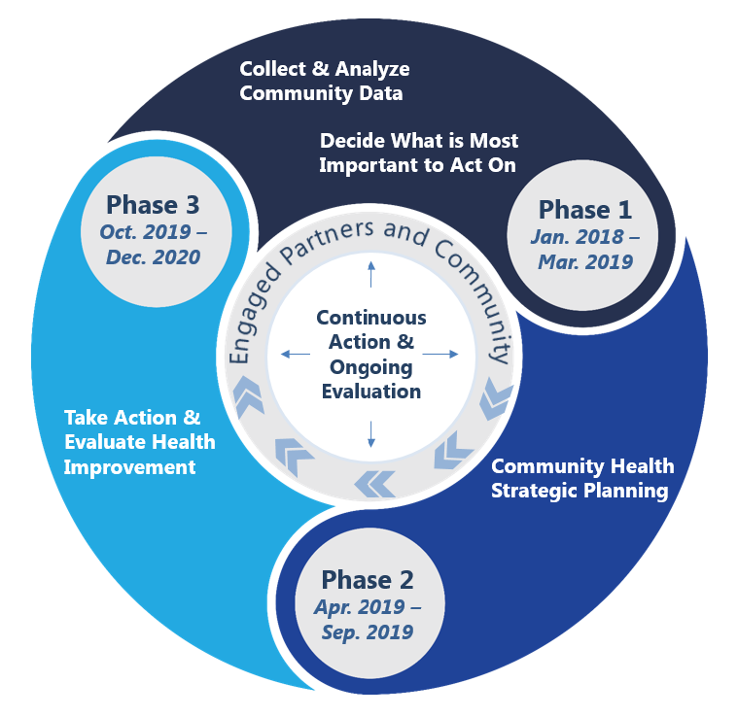

Sourced from the *Rutherford County 2018 Community Health Assessment.*

This Community Health Needs Assessment (CHNA) defines priorities for health improvement, creates a collaborative community environment to engage stakeholders, and an open and transparent process to listen and truly understand the health needs of the community served by Rutherford Regional Health System (RRHS) in Rutherford County, North Carolina.

# 2019 Community Health Needs Assessment

This document is a hospital facility-specific Community Health Needs Assessment (CHNA) for Rutherford Regional Medical Center.

Rutherford Polk McDowell Health District and Rutherford Regional Health System previously conducted a community health needs assessment in 2016. The 2019 assessment builds on the 2016 CHNA, identifying and prioritizing the current significant health needs of the community while considering the impact of actions taken to address the significant health needs identified in the 2016 CHNA. RRHS, as a co-sponsor of this assessment through their membership in WNC Healthy Impact, was a collaborative partner of the Rutherford Polk McDowell Health District in creating the community health needs assessment. WNC Healthy Impact is a partnership between hospitals and health departments in western North Carolina to improve community health. All these parties – RRHS, Rutherford Polk McDowell Health District and WNC Healthy Impact will be known in this document as the “consortium”.

Much of the content in this report is taken from the 2018 Rutherford County Community Health Assessment written by the Rutherford Polk McDowell Health District. References to this report will be cited as Rutherford County CHA, 2018. The consortium’s report is available in its entirety in the Rutherford County 2018 Community Health Assessment available in a separate document. The full report can be found here: <http://www.foothillshd.org/images/forms/1000/1120/cha/2018/RPM1120.001.2018-R.pdf>

RRHS’s board of directors approved and adopted this CHNA on August 18, 2019.

Starting on September 15, 2019, this report is made widely available to the community via RRHS’s website, www.myrutherfordregional.com, and paper copies are available free of charge at the RRHS hospital at 288 S. Ridgecrest Street, Rutherfordton, NC 28139 or by phone (828) 286-5000.

## Participants

245 community and health care organizations and individuals collaborated to create a CHNA focused on identifying and defining significant health needs, issues, and concerns of the Rutherford County. The yearlong process centered on gathering and analyzing data as well as receiving input from persons who represent the broad interests of the community and have special knowledge of or expertise in public health to provide direction for the community and hospital to create a plan to improve the health of the community.

## Project Purpose and Goals

A community health needs assessment (CHNA) is an important part of improving and promoting the health of county residents. A CHNA, which is a process that results in a public report – describes the current health indicators and status of the community, what has changed, and what still needs to change to reach a community’s desired health-related results. (Taken in part from the Rutherford County CHA, 2018) RRHS goals for the process were:

1. To continue to partner with the Rutherford Polk McDowell Health District and WNC Healthy Impact in a formal and comprehensive community health assessment process that allows for the identification and prioritization of significant health needs of the community to allow for resource allocation, informed decision-making and collective action that will improve health.
2. To continue the collaborative partnership between all stakeholders in the community by seeking input from persons who represent the broad interests of the community.
3. To continue to support the existing infrastructure and utilize resources available in the community to instigate health improvement in the community.

“We collaborated with the Health District and WNC Healthy Impact for the Community Health Needs Assessment with the goal of analyzing significant health needs and priorities and addressing those needs,” said Rebecca Segal, Chief Executive Officer, Rutherford Regional Health System. “It is our goal to use the findings as a catalyst for community mobilization to improve the health of our residents.”

“The information gathered both from public health data and from community members and stakeholders provided the insight the community needed to set priorities for significant health issues and will be used by the Rutherford Polk McDowell District Health Department, RRHS and other community organizations and stakeholders to create an implementation plan.” added Christopher Munton, Assistant Administrator, Rutherford Regional Health System.

Additionally, the consortium created a community results statement – Healthy, happy and active people in Rutherford County.

# Community Input and Collaboration

“Many key partners participated in this process. All entities and organizations provided great insight and expertise. Team members worked together and independently to gather and analyze primary and secondary data. Contributing viewpoints also included secondary data such as demographics, socioeconomics, health and environmental health indicators.”

Rutherford County CHA 2018, p. 6.

Including input from the community is a critical element of the community health assessment process. Our county included community input and engagement in a number of ways:

* Partnership on conducting the health assessment process
* Through primary data collection efforts (survey, key informant interviews)
* By reviewing and making sense of the data to better understand the story behind the numbers
* In the identification and prioritization of health issues

In addition, community engagement is an ongoing focus for our community and partners as we move forward to the collaborative planning phase of the community health improvement process. Partners and stakeholders with current efforts or interest related to priority health issues will continue to be engaged. We also plan to work together with our partners to help ensure that programs and strategies in our community are developed and implemented with community members and partners.

Rutherford County CHA, 2019 p.11

## Data Collection and Timeline

In January 2018, RRHS began working with WNC Healthy Impact and the Rutherford Polk McDowell Health District to conduct a Community Health Needs Assessment for Rutherford County. The consortium sought input from persons who represent the broad interests of the community using several methods:

* Information gathering, using secondary public health sources, occurred in January through December of 2018.
* 18 key informant surveys were completed by key community leaders, health providers, public and public health representative. The surveys were sent via e-mail to gain their perspectives on community health priorities and what is helping/hurting the community’s ability to make progress on health issues from May 1 to May 22, 2018.
* 200 community surveys were conducted by phone (landline, cell phone) and online surveys from March to June, 2018 by Professional Research Consultants, Inc. (PRC) to supplement the secondary dataset, allow individual counties in the region to collect data on specific issues of concern and hear from community members about their concerns and priorities.
* A community forum was held on December 17, 2018 to present CHA data and evidence-based strategies were explored to address the two chosen health priority areas.
* Meeting to review data and uncover issues affecting the most people in the community resulting in seven significant health issues in the county on November 2nd, 2018 of a small group of the CHNA leadership.
* Meeting using criteria and a modified Hanlon method to rate priorities resulted in the top two priority health issues on November 7th, 2018 with the Health Council.
* CHA Community Forum was held on December 17, 2018 consisting of partner organizations and community members where the CHNA data was presented and community input on potential strategies to move the health priorities forward was received.
* The implementation plan was developed between August and September 2019
* The Rutherford Regional Health System board approved the Community Health Needs Assessment, priorities and implementation plan on October 27, 2019.

Participation in the key informant survey, Community Forum significant health issues identification and prioritization meetings creating the Rutherford County Community Health Needs Assessment and Improvement Plan:

|  |  |  |
| --- | --- | --- |
| **Organization** | **Role/Contribution** | **Population Represented** |
| Community Health Council of Rutherford County | Member of CHA Advisory Committee & Data Analysis |  |
| Rutherford Regional Health System | Member of CHA Advisory Committee & Data Analysis |  |
| Blue Ridge Health - Rutherford | Member of CHA Advisory Committee & Data Analysis |  |
| Rutherford Regional Health System | Member of CHA Advisory Committee & Data Analysis |  |
| United Way; Substance Abuse Committee & Community Engagement Team | Prioritization, CHA Leadership |  |
| Cooperative Extension; Healthy Eating Committee | Prioritization, CHA Leadership |  |
| Daily Courier | Newspaper Coverage |  |
| Rutherford-Polk-McDowell Health District | CHA Leadership, Author of report |  |
| Community Health Council of Rutherford County |  |  |
| Senior Center |  |  |
| District Attorney |  |  |
| Rutherford County Schools |  |  |
| Hospice of the Carolina Foothills |  |  |
| Safe Kids |  |  |
| Levine Cancer Institute |  |  |
| VAYA |  |  |
| Sheriff |  |  |
| Pisgah Legal |  |  |
| Rutherford Life Services |  |  |
| Isothermal Community College |  |  |
| Transportation Services |  |  |
| RHI Legacy Foundation |  |  |
| Chamber of Commerce |  |  |
| Family Preservation |  |  |
| Daily Courier |  |  |
| Rutherford Outdoor Coalition |  |  |
| Rutherford County Schools |  |  |
| Board of Health |  |  |
| Chiropractor |  |  |
| Gentiva |  |  |
| Partnership for Children |  |  |
| Rutherford County |  |  |
| Rutherford County Health Center |  |  |
| Western Highlands |  |  |

## Input of Public Health Officials

Rutherford Polk and McDowell Health District was integral in the consortium leadership, gathering the secondary community health information, analyzing the primary and secondary data and writing the CHA report.

## Input of Medically Underserved, Low-Income and Minority Populations

The previous identifies each organization that was involved in the CHNA , how they provided their input and what groups they represented. Many of the organizations involved represent the medically underserved, low income and minority populations. Input was received during meetings and forum. Participants were invited based on their ability to represent the medically underserved, low-income and minority populations.

“Throughout our community health assessment process, our team was focused on understanding general health status and related factors for the entire population of our county as well as the groups particularly at risk for health disparities or adverse health outcomes. For the purposes of the overall community health assessment, we aimed to understand differences in health outcomes, correlated variables, and access, particularly among medically underserved, low-income, and/or minority populations, and others experiencing health disparities.

The at-risk and vulnerable populations of focus for our process and product include:

* Low-income
* Minority
* Un-insured or under-insured
* Current smokers and/or who abuse substances
* Those who are sedentary and who are obese/overweight
* Those experiencing health disparities
* The elderly
* Children
* The disabled

Rutherford County CHA, 2019 p.12

# Community Selected for Assessment

“Community is defined as "county" for the purposes of the North Carolina Community Health Assessment Process. Rutherford County is included in Rutherford Regional Health System’s community for the purposes of community health improvement, and as such they were key partner in this local level assessment.” Rutherford County CHA, 2019 p.10

75% of RRHS’s inpatients come from Rutherford County. Therefore, it is reasonable to select Rutherford County as the primary focus of the CHNA.

The community identified by RRHS includes medically underserved, low-income or minority populations who live in the geographic areas from which RRHS draws its patients. All patients were used to determine the service area without regard to insurance coverage or eligibility for financial assistance under RRHS’s Financial Assistance Policy.

# Elements of a Healthy Community

When key informants were asked to describe what elements, they felt contributed to a health community in our county, they reported:

* Healthy Lifestyles
* Lower Obesity Rates
* Awareness/Education
* Good Economy

“During our collaborative planning efforts and next steps, we will further explore these concepts and the results our community has in mind.” Rutherford County CHA, 2019 p.15

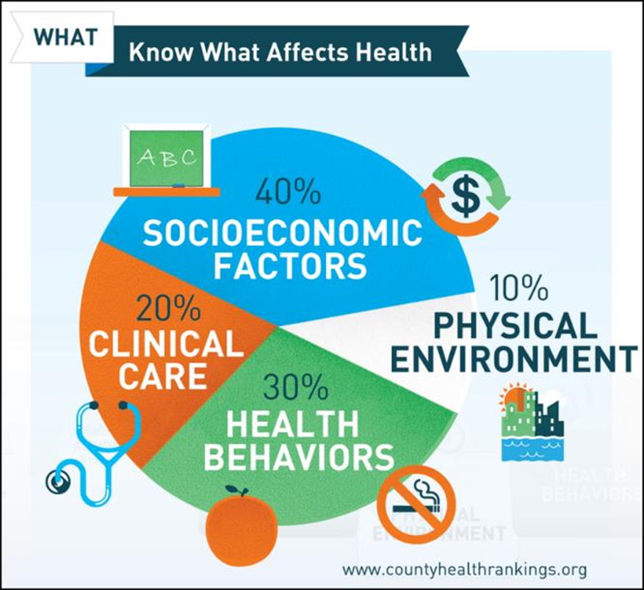

# Key Findings of the Community Health Assessment

## Results

Based on the primary and secondary data, the following needs were prioritized by CHNA leadership and the Health Council.

* Active Living
* Substance Abuse Treatment and Recovery

## Information Gaps and Limitations

“While this assessment is quite comprehensive, it cannot measure all possible aspects of health in the community, nor can it adequately represent all possible populations of interest. It must be recognized that these information gaps might in some ways limit the ability to assess all of the community’s health needs.

In terms of content, this assessment was designed to provide a comprehensive and broad picture of the health of the overall community. However, there are certainly a great number of medical conditions that are not specifically addressed.” Rutherford County CHA, 2019 p.51

“The set of data reviewed for our community health assessment process is comprehensive, though not all of it is presented in this document. Within this community health assessment, we share a general overview of health and influencing factors, then focus more on priority health issues identified through a collaborative process. Our assessment also highlights some of our community strengths and resources available to help address our most pressing issues.” Rutherford County CHA, 2019 p.10

## Processes and Methods

The set of data reviewed for our community health assessment process is comprehensive, though not all of it is presented in this document. Within this community health assessment product, we share a general overview of health and influencing factors, then focus more on priority health issues identified through this collaborative process. Our assessment also highlights some of our community strengths and resources available to help address our most pressing issues.

### Core Dataset Collection

The data reviewed as part of our community’s health assessment came from the WNC Healthy Impact regional core set of data and additional local data compiled and reviewed by the local CHA team. WNC Healthy Impact’s core regional dataset includes secondary (existing) and primary (newly collected) data compiled to reflect a comprehensive look at health. The following data set elements and collection are supported by WNC Healthy Impact data consulting team, a survey vendor, and partner data needs and input:

* A comprehensive set of publicly available secondary data metrics with our county compared to the sixteen county WNC region
* Set of maps accessed from Community Commons and NC Center for Health Statistics
* WNC Healthy Impact Community Health Survey (cell phone, landline and Internet-based survey) of a random sample of adults in the county
* Online key-informant survey

Rutherford County CHA, 2019 p.11

The comprehensive data analysis may be obtained on RRHS’s website www.myrutherfordregional.com, and paper copies are available free of charge at the RRHS hospital at 288 S. Ridgecrest Street, Rutherfordton, NC 28139 or by phone (828) 286-5000.

# Demographics of the Community

* In 2016 the total population of Rutherford County was 66,701.
* There is a lightly higher proportion of females than males (51.4% female, 48.6% male) and 19.5% of the population is 65 years and older (U.S. Census Bureau, 2018).
* The majority or residents are White (85.5%) with minorities represented as follows: Black or African American (10.3%), Hispanic or Latino (4.0%), Asian (0.5%), American Indian/Alaska Native (0.5%), and Native Hawaiian and other Pacific Islander (0.0%). (U.S. Census Bureau, 2018).
* Additionally, the population for Rutherford County is expected to change at an alarmingly low rate of only 0.4% from 2020 to 2030 with a projected population total of 68,312 in 2030 and the rate will continue to decrease thereafter (NC Office of State Budget Management, 2018).

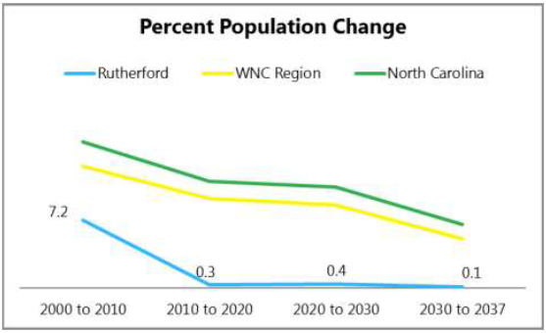

Source: NC Office of State Budget Management

* The median age in Rutherford County is 44.1 while the median age in the region is 45.9 and 38.3 in the state (U.S. Census Bureau, 2018). It is projected that in 2037, 24.8% of the population will be 65 years and older (North Carolina Office of State Budget and Management, 2018).
* Meanwhile, the birth rate trend has steadily decreased over the years from 10.4 during 2009-2013 to 10.2 during 2010-2014 to 10.1 during 2011-2015 and 10.0 during 2012-2016.
* Furthermore, among the total population age 25 and older, Rutherford County has a 31.9% high school graduation rate, 21.2% some college with no degree and 16.7% who have a bachelor’s degree or higher (U.S. Census Bureau, 2018). The high school graduation rate is higher than that of the state and the region and the percentages of some college and bachelor’s degree of higher are in line with and lower than the state and region respectively. Lastly, 4.6% of Rutherford County households are non-English speaking (U.S. Census Bureau, 2018).

# Health Status Data Summary

The following is taken from the Rutherford County Community Health Assessment 2018.

## Social and Economic Factors

### Income & Poverty

“Income provides economic resources that shape choices about housing, education, child care, food, medical care, and more. Wealth, the accumulation of savings and assets, helps cushion and protect us in times of economic distress. As income and wealth increase or decrease, so does health” (County Health Rankings, 2018).

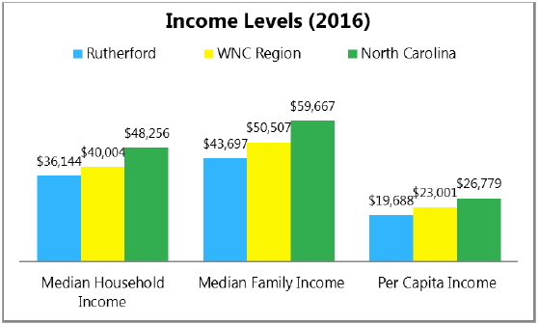 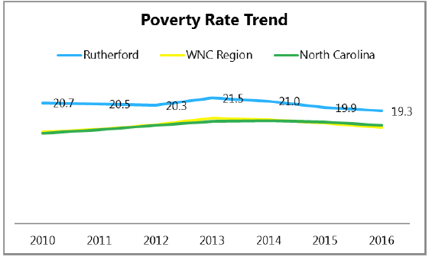

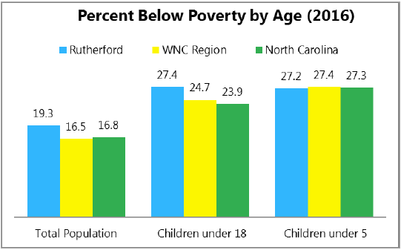

Source: U.S. Census Bureau

* Median household income is $36,144.
* Median family income is $43,697.
* Per capita income is $19,688.
* 19.3% of the total population is below poverty level. This is higher than both the WNC region (16.5%) and the state (16.8%).

### Employment

“Employment provides income and, often, benefits that can support healthy lifestyle choices. Unemployment and under employment limit these choices, and negatively affect both quality of life and health overall. The economic condition of a community and an individual’s level of educational attainment both play important roles in shaping employment opportunities”

(County Health Rankings, 2018).

* The 2018 Annual Summary indicates that in Rutherford County the largest employment sector is manufacturing with an employment percentage of 16.08% and weekly wage of$845.58.
* This is followed by 15.46% in health care and social assistance with a weekly wage of $649.09 and finally 13.86% in retail trade with a weekly wage of $459.67.
* The unemployment annual average, unadjusted rate in 2017 was 6.1.

### Education

“Better educated individuals live longer, healthier lives than those with less education, and their children are more likely to thrive. This is true even when factors like income are taken into account” (County Health Rankings, 2018).

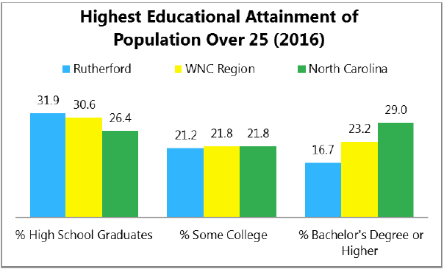 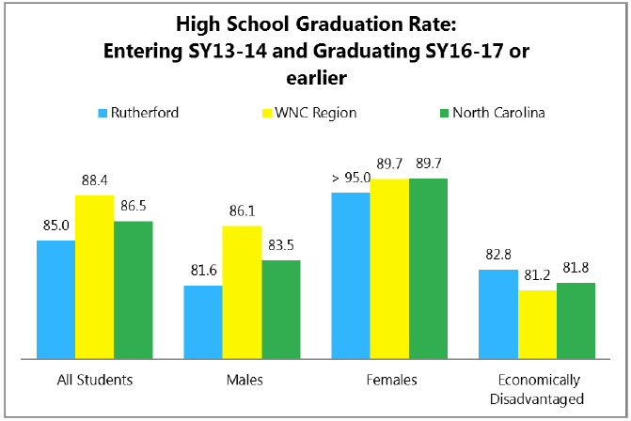

Source: U.S. Census Bureau Source: Public Schools of North Carolina

### Community Safety

“Injuries through accidents or violence are the third leading cause of death in the United States, and the leading cause for those between the ages of 1 and 44. Accidents and violence affect health and quality of life in the short and long-term, for those both directly and indirectly affected, and living in unsafe neighborhoods can impact health in a multitude of ways” (County Health Rankings, 2018).

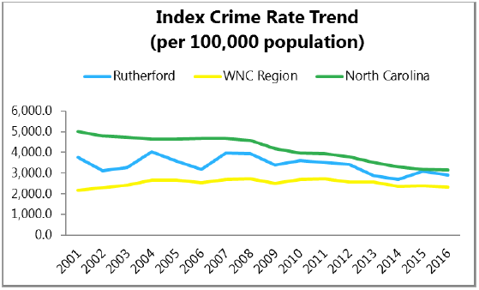

Source: NC Department of Justice

Index crime is the sum of all violent and property crime. The index crime rate in Rutherford County fell above the comparable regional rate and below the comparable state rate throughout the period cited.

### Housing

“The housing options and transit systems that shape our community’s built environments affect where we live and how we get from place to place. The choices we make about housing and transportation, and the opportunities underlying these choices, also affect our health” (County Health Rankings, 2018).

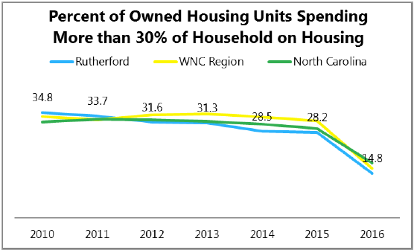 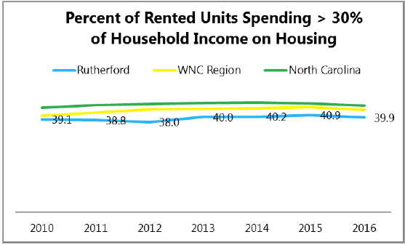

Source: U.S. Census Bureau

* One measure of economic burden in a community is the percent of housing units spending more than 30% of household income on housing (rented and owned units). In Rutherford County, 14.8% of housing units spend more than 30% of household income on owned units and 39.9% on rented units. Both rates are slightly lower than the state and region rates.
* Median gross rent is $602 and median monthly owner costs is $953 during the 2012-2016 time period.

### Family & Social Support

“People with greater social support, less isolation, and greater interpersonal trust live longer and healthier lives than those who are socially isolated. Neighborhoods richer in social capital provide residents with greater access to support and resources than those with less social capital” (County Health Rankings, 2018).

In 2018, 66.8% of Rutherford County adults self-report to “Always/Usually” get needed social/emotional support.

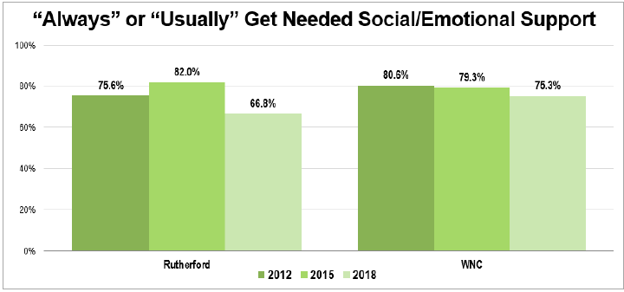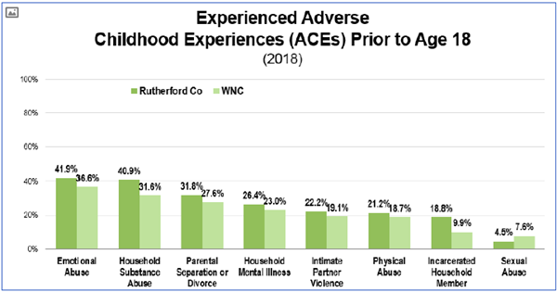

Source: WNC Healthy Impact Community Health Survey

Of the Rutherford County adults that have experienced Adverse Childhood Experiences (ACEs) prior the Age 18, the majority, at 41.9%, experienced emotional abuse, 40.9% experienced household substance abuse, and 26.4% experienced household mental illness. All county rates, with the exception of sexual abuse, are higher than that of WNC region rates.

## Health Data Findings Summary

### Mortality

The table below shows that the three leading causes of death for the period 2012-2016 were

Diseases of the Heart, Cancer, and Chronic Lower Respiratory Disease.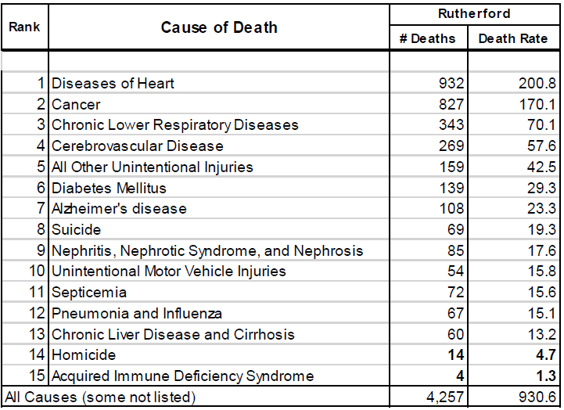

Source: NC State Center for Health Statistics

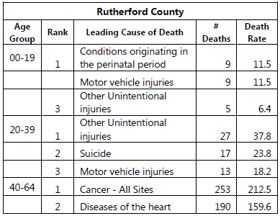

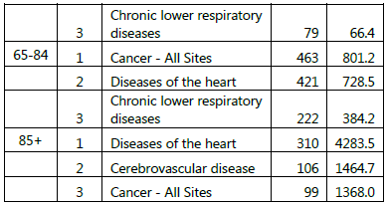

Source: NC State Center for Health Statistics

When looking at the leading causes of death by age group, other unintentional injuries, suicide and motor vehicle injuries are the leading causes for young adults ages 20-39. As the population ages, chronic diseases become predominant including cancer, diseases of the heart and chronic lower respiratory diseases.

The overall life expectancy for residents in Rutherford County is 75.3 years. This is lower than both that of WNC (77.7 years) and NC (77.4 years). For persons born in 2014-2016, life expectancy is longer among females (78.2 years) than males (72.4 years) and for White residents (75.7 years) than African American residents (73.4 years).

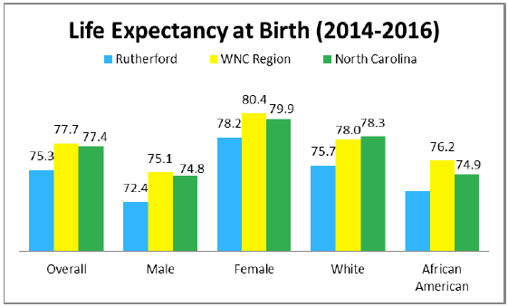

Source: NC State Center for Health Statistics

Note how poorly males in Rutherford County fare compared to females in terms of mortality when looking at Total Cancer Mortality Rates. History demonstrates that this is not a new observation nor is it unique to WNC. Potential reasons that explain this phenomenon include activities that are generally higher among women such as utilization of preventative care, medical check-ups, and participation in screening events. Meanwhile, risky behaviors such as smoking, substance abuse, and poor diet are generally higher among men.

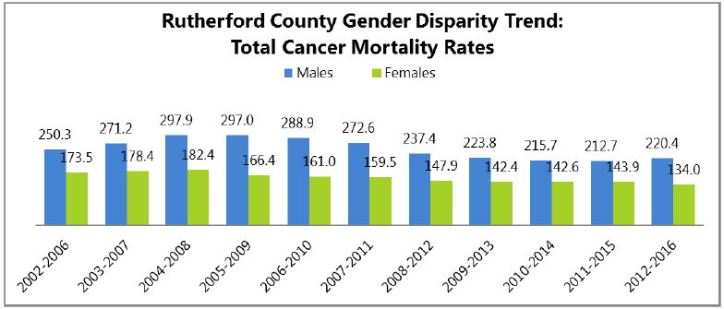

Source: NC State Center for Health Statistics

### County Health Rankings – Outcomes and Factors

The 2018 County Health Rankings ranked Rutherford County 74th overall among 100 NC Counties where number 1 is the best (County Health Rankings, 2018).

In terms of health outcomes, Rutherford County ranked:

* 83rd in length of life
* 54th in quality of life (includes poor or fair health, poor physical health days, poor mental health days, and low birthweight).

In terms of health factors, Rutherford County ranked:

* 50th in health behaviors (includes adult smoking, adult obesity, food environment index, physical inactivity, access to exercise opportunities, excessive drinking, alcohol-impaired driving deaths, sexually transmitted infections and teen births).
* 57th in clinical care (includes uninsured, primary care physicians, dentists, mental health providers, mammography screenings, and more).
* 69th in social and economic factors (includes high school graduation, unemployment, children in poverty, social associations, violent crime, and more).
* 34th in physical environment (includes air pollution-particulate matter, drinking water violations, severe housing problems, and more).

Self-reported overall health status has deteriorated in the past 3 years as the percentage of adults experiencing “fair” or “poor” overall health has increased from 17.7% to 25.3%. Rutherford County rates are higher than that of the region, the state, and the country.

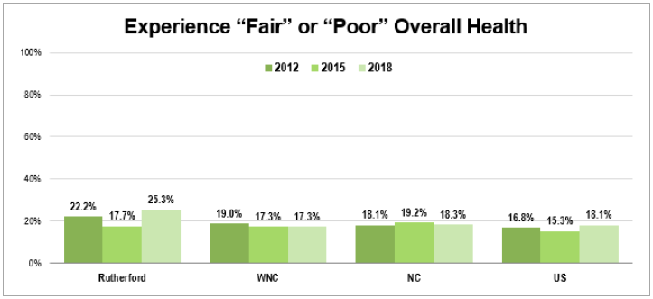

Source: WNC Healthy Impact Community Health Survey

### Maternal & Infant Health

The total pregnancy rates in Rutherford County for women aged 15-44 shows to have remained steady overall in the last several years. This downward trend is mirrored in that of the WNC and NC rates, with rates being 64.9 (Rutherford), 63.5 (WNC) and 72.2 (NC) in 2016 (NC State Center for Health Statistics, 2018). Teen pregnancy rates in Rutherford County, WNC, and NC have fallen significantly since the 2002-2006 period and seem to continue a downward trend.

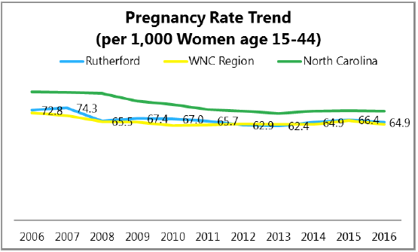 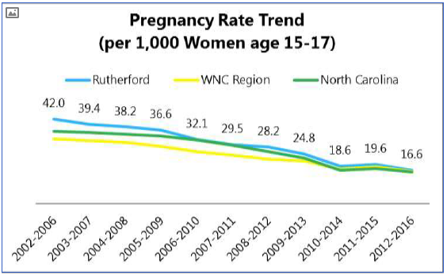

Source: NC State Center for Health Statistics

Furthermore, among Rutherford County women ages 15-44 years, in 2016 the highest pregnancy rates appear to occur among Hispanics. Meanwhile, among teens age 15-19 in Rutherford County, the highest pregnancy rates appear to occur among White, non-Hispanics.

A pregnancy risk factor in Rutherford county includes smoking during pregnancy. In 2016 the rate of women who smoked during pregnancy in Rutherford County (20.5), although not the highest in the region, is higher than the WNC rate (19.9) and significantly higher than the state rate (8.9) (NC State Center for Health Statistics, 2018). In addition, the percentage of women in Rutherford County who received prenatal care in the first trimester (months 1-3) has overall steadily decreased since 2011 when it was 77.8% to 70.7% in 2016 (NC State Center for Health Statistics, 2018).

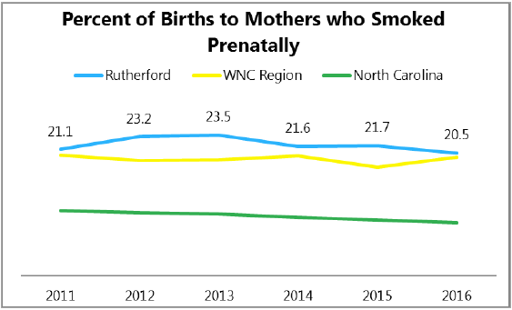

Source: NC State Center for Health Statistics

### Chronic Disease

Rutherford County has considerably high rates of diabetes, high blood pressure, high cholesterol, heart disease, cancer, and chronic lower respiratory disease.

Diabetes

The average self-reported prevalence of Rutherford County adults with diabetes was 20.3 in 2018, which is a dramatic increase from 10.2% in 2015. Similarly, the WNC region has also seen an increase in the prevalence of diabetes as its percentage grew from 7.5% in 2015 to 14.4% in 2018 (WNC Health Network, 2018).

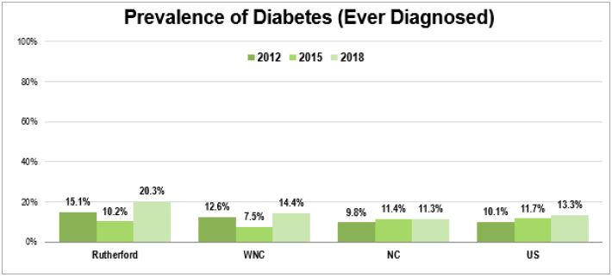

Source: WNC Healthy Impact Community Health Survey

Hypertension and Heart Disease

Additionally, in 2018 the self-reported prevalence of high blood pressure in Rutherford County adults was 45.1% while the percentage for the state was 35.2% and 39.2% for the WNC region. The prevalence of high cholesterol was 42.7% for Rutherford county and 33.8% for the WNC region (WNC Health Network, 2018).

Furthermore, heart disease is the leading cause of death in Rutherford County followed by cancer and the third cause being chronic lower respiratory diseases. In 2018 over 11% of Rutherford County residents were diagnosed with heart disease (to include heart attack, angina, or coronary disease). This prevalence was higher than that of WNC (8%).

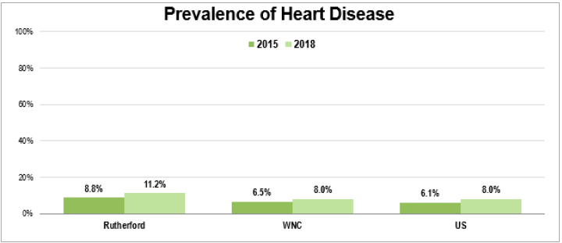

Source: WNC Healthy Impact Community Health Survey

Cancer

Cancer incidence rates for site-specific cancers for this community including colorectal (42.7), lung (71.1) and prostate (100.9) cancers were higher than that of the WNC region (38.3, 66.7, and 87.9 respectively) (NC State Center for Health Statistics, 2018).

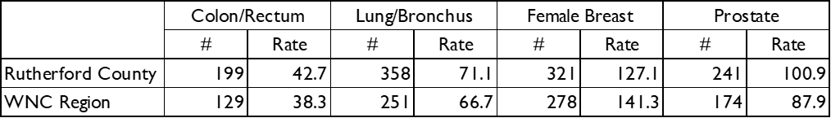

Source: NC State Center for Health Statistics

### Injury & Violence

For age groups 00-19 and 20-39, injuries, whether motor vehicle or unintentional, are within the leading cause of death for Rutherford County residents (NC Center for Health Statistics, 2018). Of these, the main injuries that lead to death or debilitation in our community include falls, unintentional poisonings, and motor vehicle crashes.

### Mental Health & Substance Abuse

Between 2006 and 2017, the number of Rutherford County residents served by an Area Mental Health Program decreased overall from 3,510 to 1,782 (a 49% decrease). However, in 2018 23.7% of Rutherford County adults self-reported having greater than 7 days of poor mental health in the past month. This is an increase from 2015 when the percentage was 16.2%. Also 14.8% reported not getting the mental health care or counseling what was needed in the past year, which is also an increase from 2015 when the percentage was 8.9% (WNC Health Network, 2018). The decrease in utilization begs the question: where are those in need being treated? In emergency rooms, jails, not at all?

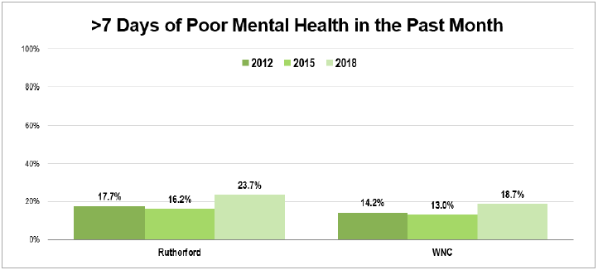 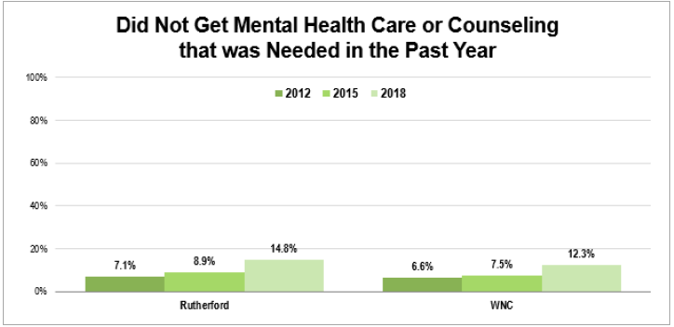

Source: WNC Healthy Impact Community Health Survey

Moreover, between the years of 2009-2013, 94% of unintentional poisoning deaths in Rutherford County were medication/drug overdoses (Injury Epidemiology and Surveillance Unit, Injury and Violence Prevention Branch, Chronic Disease and Injury Section, N.C. Division of Public Health, 2015). Additionally, in the first quarter of 2018 there were 21 EMS naloxone administrations and 9 community naloxone reversals by a community lay person, not including first responders. Lastly, it is alarming that the year to date total as of the 4th quarter in 2017 of opioid pills dispensed in Rutherford County was 5,449,000 pills. It is of note that substance abuse treatment and recovery services came up as a need during community discussions.

### Oral Health

In 2018, 52.2% of Rutherford County adults indicated having had a dental visit in the past year. This is a decrease from prior years as the percentage in 2015 was 55.8% and 57.6% in 2012. Meanwhile, in 2018 the average for the WNC region was 61.6% and 63.6% for the state, which also indicates a slight decrease from years prior.

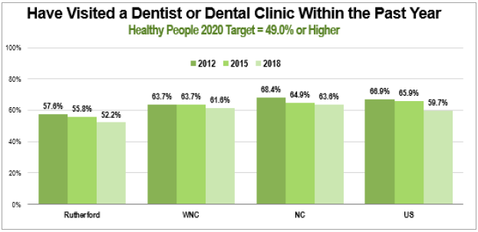

Source: WNC Healthy Impact Community Health Survey

### Clinical Care & Access

Health Insurance

Many insurance navigators continue to work tirelessly to assist those seeking insurance through the exchange and help them qualify for subsidies. Although many are still unable to afford policies, the numbers for Rutherford County residents has seemed to improve. In 2012 31.4% of Rutherford county adults (ages 18-64) self-reported not having health insurance. This percentage decreased to 18.1% in 2015 and decreased even further to 13.3% in 2018. The rates for the WNC region and the state are higher than that of Rutherford county showing 19.8% and 17.1% respectively in 2018 (WNC Health Network, 2018). Additionally, it is estimated that in 2016 95.5% of children through the age of 18 years had health insurance coverage (U.S. Census Bureau).

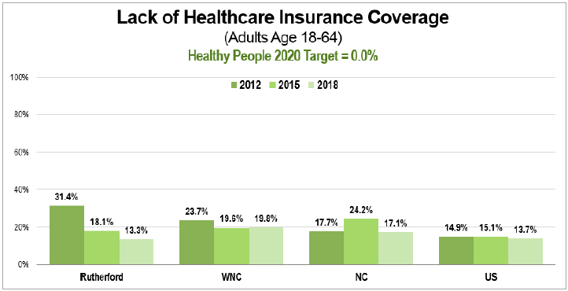 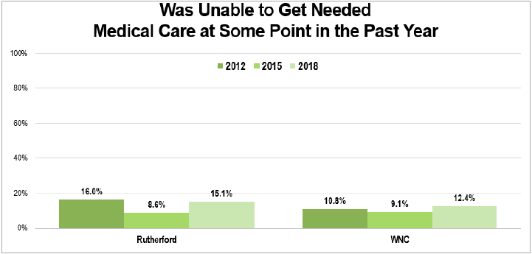

Source: WNC Healthy Impact Community Health Survey

Even though the number of adults in Rutherford County who reported to be un-insured has decreased over the years, 15.1% have indicated they have been unable to get needed medical care at some point in the past year. This is an increase from 8.6% in 2015 and is higher than the WNC region average of 12.4% for 2018. This demonstrates that although very important, other than health insurance, there are other factors that inhibit access to healthcare including the lack of reliable transportation, financial constraints, lack of adequate childcare, and lack of knowledge about available resources, among others.

## Physical Environment

### Air & Water Quality

“Clean air and safe water are prerequisites for health. Poor air or water quality can be particularly detrimental to vulnerable populations such as the very young, the elderly, and those with chronic health conditions. Clean air and water support healthy brain and body function, growth, and development. Air pollutants such as fine particulate matter, ground-level ozone, sulfur oxides, nitrogen oxides, carbon monoxide, and greenhouse gases can harm our health and the environment. Excess nitrogen and phosphorus run-off, medicines, chemicals, lead, and pesticides in water also pose threats to well-being and quality of life” (County Health Rankings, 2018).

Alarmingly, in 2015, Rutherford County ranked number 1 among 85 counties reporting Toxic Release Inventory with a total release of 9,947,634 pounds. Together, Horsehead Metal Products LLC, Duke Energy LLC – Rogers Energy Complex, Eaton Aeroquip Inc., and Trelleborg Coated Systems US Inc./Grace Advanced Materials make up the largest contributors of compounds released at a quantity 9,155,495 pounds.

Furthermore, secondhand smoke is a known human carcinogen with more than 7,000 chemical compounds of which 250 are known to be harmful and 69 of which cause cancer (American Cancer Society, 2014). Smoking is known to cause lung cancer in humans and is a major risk factor for heart disease. The more secondhand smoke is inhaled, the higher the level of these harmful chemicals will be in the body. In 2018, 18.3% of Rutherford County employed adults indicated they had breathed in someone else’s smoke at work in the past week. This is a slight increase from 2015 when the average was 13.7% and is higher than the WNC region average of 17% (WNC Health Network, 2018).

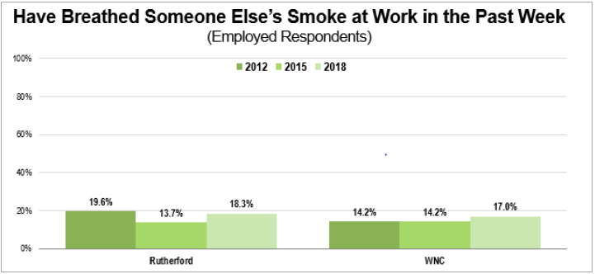

Source: WNC Healthy Impact Community Health Survey

Clean water is also a prerequisite for health. Having access to clean water supports healthy brain and body function, growth and development. While drinking water safety is improving, many contaminants still pollute our water sources – pharmaceuticals, chemicals, pesticides, and microbiological contaminants. In Rutherford County, as of July 2018, 41,653 (or 62.4%) of the county’s 2016 population of 66,701 was served by community water systems (Safe Drinking Water Information System, 2018). The remainder of the population accesses water from wells or from bottled water.

### Access to Healthy Food & Places

“Food security exists when all people, at all times, have physical, social and economic access to sufficient, safe and nutritious food to meet their dietary needs and food preferences for an active and healthy life (Food and Agriculture Organization, 2006). The environments where we live, learn, work, and play affect our access to healthy food and opportunities for physical activity which, along with genetic factors and personal choices, shape our health and our risk of being overweight and obese. As of 2013, 29 million Americans lived in a food desert, without access to affordable, healthy food. Those with lower education levels, already at-risk for poor health outcomes, frequently live in food deserts” (County Health Rankings, 2018).

In Rutherford County, approximately 13 grocery stores and three farmers markets exist to serve the 66,701 residents. In 2015, it was indicated that 4.39% of households had low access to a supermarket or large grocery store, meaning a household without a car and more than 1 mile from a supermarket or large grocery store (U.S. Department of Agriculture Economic Research Service, 2018). In 2018, more than half of Rutherford County adults, 56.8%, indicated that they “never” have had to worry/stress about having enough money to buy nutritious meals in the past year, which is an improvement from 2015 when the percentage was 49.2% (WNC Health Network, 2018).

Lastly, as of 2014 there were 39 fast food restaurants in Rutherford County and only 4 recreational facilities (U.S. Department of Agriculture Economic Research Service, 2018). Limited opportunities for recreation including a lack of access to a safe place to recreate, whether an indoor facility or a park, greenway, walking trail or playground, etc., hinders the ability for a person to live an active lifestyle. This can affect other areas of their health including being overweight or obese and by extension cause the onset of chronic disease.

# Identification of Health Priorities

## Process

Every three years we pause our work to improve community health so that we may step back and take a fresh look at all of the current data from our county that reflects the health of our community. We then use this information to help us assess how well we’re doing, and what actions we need to take moving forward.

Beginning in September 2018, our team spent time understanding the data and uncovering what issues were affecting the most people in our community. We also interviewed community leaders to find out what they’re most concerned about. To identify the significant health issues in our community, our key partners (see a full list on page 9) reviewed data and discussed the facts and circumstances of our community.

We used the following criteria to identify significant health issues:

* Data reflects a concerning trend related to size or severity
* Significant disparities exist
* Issue surfaced as a high community concern
* County data deviates notably from the region, state or benchmark

Once our team made sense of the data, we presented key health issues to a wide range of partners and community members. The participants used the information we presented to score each issue, and then vote for their top areas of concern. Some of the factors they considered were how much the issue impacts our community, how relevant the issue is to multiple health concerns, and how feasible it is for our community to make progress on this issue.

This process, often called health issue prioritization, is an opportunity for various community stakeholders, such as the Rutherford County Health Department, Rutherford Regional Health System, the Community Health Council of Rutherford County, Blue Ridge Health Rutherford, and others to agree on which health issues and results we can all contribute to, which increases the likelihood that we’ll make a difference in the lives of people in our community.

## Identified Issues

During the above process, the Data Analysis Team identified the following health issues or indicators:

* **Cancer:** Although decreasing, the total cancer mortality trend for Rutherford County is still higher than that of the WNC region at the state.
* **Healthy Eating:** Over one third of Rutherford County residents state they experience food insecurity and only 7% indicate they are consuming five or more servings of fruits and vegetables per day.
* **Active Living:** Only 16.5% of Rutherford County residents meet recommended physical activity guidelines, which is lower than the WNC region and the state, and 77.1% of Rutherford County residents are overweight or obese.
* **Substance Abuse Treatment & Recovery:** Although diseases of the heart are the leading cause of death overall for Rutherford County residents, unintentional injuries are the leading cause of death for young adults ages 20-39. The rate of unintentional injuries has steadily increased since 2009 and is significantly higher than the state rate.
* **Tobacco:** The rates of current smokers remains higher than that of the WNC region and the state, meanwhile, the rate of those who currently use smokeless tobacco products has nearly tripled since 2015.
* **Childhood Poverty:** Children suffer significantly and disproportionately from poverty with a rate of 27.2% for children under 5 and 27.4% for children under 18.
* **Mental Health:** There were 69 suicides during 2012-2016 with a rate of 19.3, which is much higher than the sate rate of 12.9. Mental health is also believed to be a contributor to other unhealthy behaviors and lifestyle choices including substance abuse.

# Prioritization of Health Needs

## Process and Prioritization Criteria

On November 2nd and November 7th, 2018, the CHNA leadership and Health Council met to create the health priorities. The group used the criteria below to prioritize the health needs.

|  |  |
| --- | --- |
| Relevant | How important is this issue? *(Urgency to solve the problem; community concern; Focus on equity; Linked to other important issues)* |
| Impactful | What will we get out of addressing this issue? *(Availability of solutions/proven strategies; Builds on or enhances current work; Significant consequences of not addressing issue now)* |
| Feasible | Can we adequately address this issue? *(Availability of resources (staff, community partners, time, money, equipment) to address the issue; Political capacity/will; Community/social acceptability; Appropriate socio-culturally; Can identify easy, short-term wins)* |

## Identified Priorities

Participants used a modified Hanlon method to rate the priorities using the criteria listed above. Then dot-voting and multi-voting techniques were used to narrow to the top 2 priority health issues. The following priorities were identified:

1. **Active Living** – Active living was selected because it affects many different areas of an individual’s wellbeing including their physical and emotional health. Healthy living, which includes active living, was part of the selected priorities during the 2015 Community Health Assessment and although much progress has been made in this area, much is still to be done. This is based on physical inactivity rates, overweight/obesity rates, and mental health data. Chronic disease and healthy living
2. **Substance Abuse Treatment and Recovery** –Substance abuse emerged as a health priority during the 2015 Community Health Assessment. During the 2018 Community Health Assessment, the community decided to expand this health priority to include treatment and recovery based on a notable lack of local resources to help community members combat substance abuse issues.

## Priority Issue #1 – Active Living

**Active Living** has been paired with healthy living as a health priority for Rutherford County for many years. Physical activity is an important factor affecting overall health. Regular physical activity among children and adults reduces the risk of many health issues including chronic disease and improves an individual’s mental health. Many agencies and organizations have partnered to improve this by implementing ways to increase physical activity and make better use of the county’s greenways, parks and trails. For example, the Health Department has partnered with the Community Health Council of Rutherford County, Rutherford Regional Health System, Isothermal Planning and Development Commission, Rutherford Outdoor Coalition, Region C Area Agency on Aging, and more. With a collective effort, the needle has moved and there are now more places to be active in Rutherford County and more awareness of how to access those places. Much work has been completed in this area, but much work is still to be done.



### Health Indicators

The following data points helped to inform the Active Living priority:

30.1% of Rutherford County adults reported no leisure-time physical activity in the past month in 2018. This percentage is an increase from 23.5% in 2015 and 20.8% in 2012, which indicates that more individuals are reporting an inability to engage in leisure-time physical activity (WNC Health Network, 2018). Leisure-time physical activity can include activities such as walking, dancing, swimming, gardening, sports, cycling and many others. The recommended amount of physical activity for most healthy adults is 150 minutes per week. Although Rutherford County’s rate is within the Healthy People 2020 Target of 32.6% or lower, the upward trend suggests that work is needed in this area to prevent further increases. The 2018 rate for Rutherford County exceeds comparator jurisdictions.

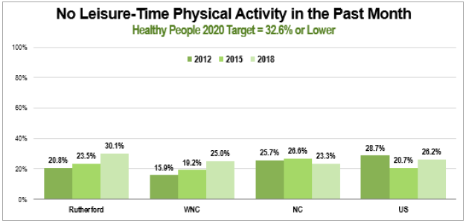 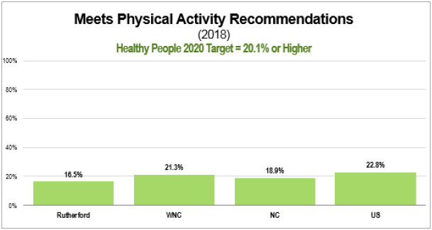

Source: WNC Healthy Impact Community Health Survey

Adults meeting the physical activity recommendation was 16.5% in 2018, but 49.8% in 2015, and 53% in 2012 (WNCHN – WNC Healthy Impact Community Health Survey, 2018). This demonstrates a dramatic decrease and is also below the Healthy People 2020 target of 20.1% or higher. Rutherford County also ranks below the WNC region and the state.

Additionally, adults at a healthy weight, meaning a Body Mass Index (BMI) between 18.5 and 24.9, in 2018 was 21.6% and 24.8% in both 2015 and 2012. The prevalence of total overweight (BMI 25 or higher) was an astonishing 77.1% in 2018 and was nearly 74% in both 2015 and 2012.

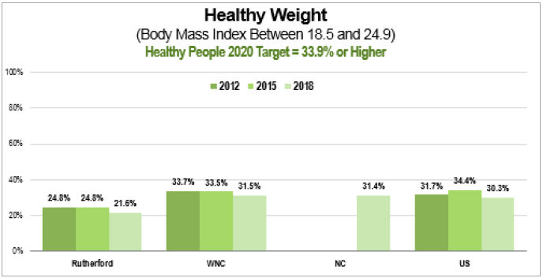 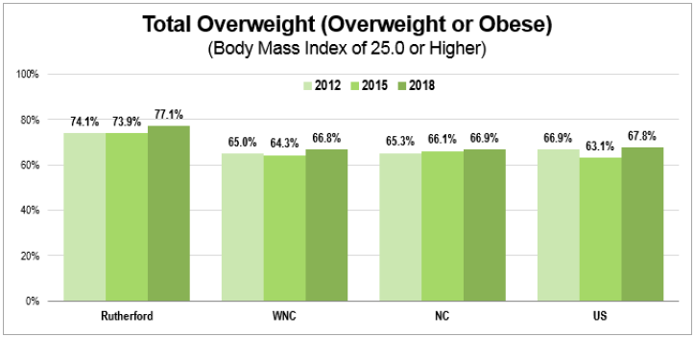

Source: WNC Healthy Impact Community Health Survey

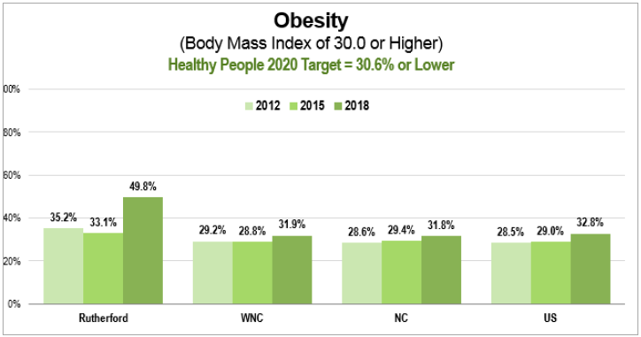

Source: WNC Healthy Impact Community Health Survey

Meanwhile, the prevalence of obesity was 49.8%, which is a significant increase from 33.1% in 2015 (WNC Health Network, 2018). The rate of adults at a healthy weight in Rutherford County in 2018 was lower than that of the WNC region and the state and the rates of individuals who are overweight or obese surpassed that of the region and the state.

Further, chronic diseases such as heart disease, cancer and diabetes are major causes of death and disability in North Carolina and in Rutherford County. Although genetics contribute to the development of these chronic health conditions, individual behaviors play a major role. The Centers for Disease Control and Prevention (CDC) explains that Physical inactivity, unhealthy eating, smoking and excessive alcohol consumption are four behavioral risk factors underlying much of the burden caused by chronic disease.

The prevalence of diabetes, self-reported, in 2018 is 20.3%. This is double the rate from 2015 when it was 10.2%. These rates are also much higher than that of the WNC region (14.4%) and the state (11.3%). Additionally, the diabetes mortality rate for Rutherford County adults overall is 29.3 and, like the prevalence of diabetes, is higher than the WNC region (21.5) and the state.

(23.0). Similarly, the prevalence of heart disease also increased from 8.8% in 2015 to 11.2% in 2018. These rates are also higher than the WNC region (42.8) and the state (43.1) (WNC Health Network, 2018).

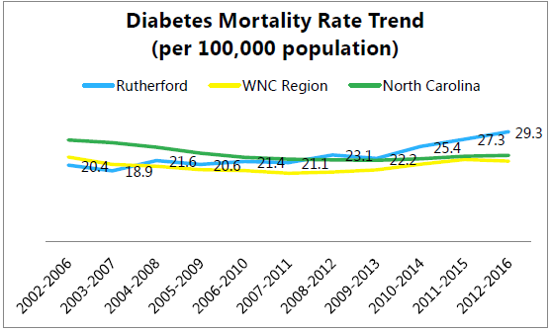 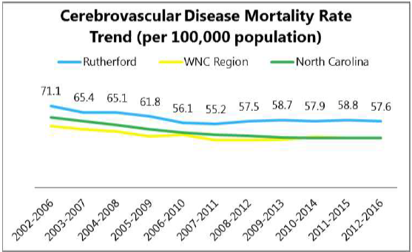

Source: NC State Center for Health Statistics

Moreover, as previously mentioned, physical activity can also have a positive impact on an individual’s mental health. Efforts to improve a person’s mental health is essential as suicide is the second leading cause of death for age group 20-39 in Rutherford County and 26.3% have reported that mental/depression problems are the cause of their activity limitations.

Mental/depression being the second largest type of problem that limits activities after the

“Other” category at 28%, exceeds back/neck problems (15%), arthritis/rheumatism (14.2%), lung/breathing problems (6.4%), difficulty walking (5.3%), and fracture/bone/joint injury (4.8%).

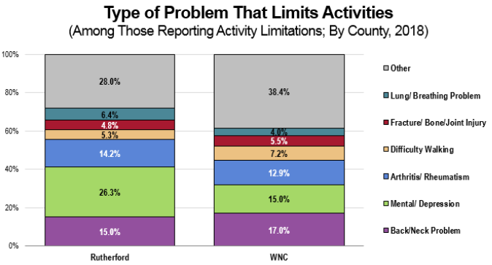

Source: WNC Healthy Impact Community Health Survey

In 2018, 18.5% of Rutherford County adults indicated they are dissatisfied with life. This is more than four times the rate in 2012 (4.3%) and nearly 3 times the rate in 2015 (6.4%). This rate is also higher than that of the WNC region. In addition, in 2018, 23.7% of the adults self-reported to having had more than 7 days of poor mental health in the past month (WNC Health Network, 2018). This rate, again, is higher than what it was in 2015 and is also higher than that of the WNC region.

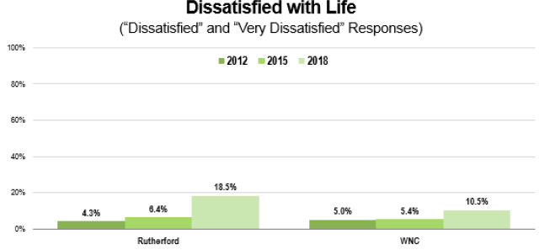

Source: WNC Healthy Impact Community Health Survey

### Community Input

Although community leaders in Rutherford County recognize that healthy lifestyle is a characteristic of a healthy community, they also understand that it is difficult to adopt healthy behaviors if an individual does not live in an environment that supports these behaviors.

Key leaders express excitement about projects that are currently underway that will provide opportunities for residents to engage in physical activity and better utilize parks, trails and greenways. When referring to the expanding rail trail, one community leader states that it “can be a game changer for our county if it becomes as popular as it is in other communities.” Another leader mentions that “the completion of our 13.8-mile thermal rail trail is making outdoor exercise more interesting and accessible.”

Stakeholders also indicate that the Rutherford County community is strengthened by the Community Health Council of Rutherford County who sponsors many events promoting healthy activity/exercise, as well as food security, strong parks and recreation program, and the collaborative efforts of many agencies working together toward a common goal.

Along with factors that are helping to improve this issue, there are also those that are hurting it. These include sedentary lifestyles, lack of consumer knowledge and interest, ingrained habits, and financial restraints. A community leader adds that another impediment is the “lack of safe places to exercise if you don’t belong to a gym” potentially due to “rural roads, or areas with no sidewalks/lighting,” etc.

### What Else Do We Know?

Males are more likely than females to get the recommended amount of physical activity. Income and education are also related to physical activity. For example, people with the least income are the least likely to achieve the recommended level of activity. Ultimately, ensuring that individuals at all levels of the community are aware of available resources is of utmost importance (Healthy NC 2020, 2011).

### What is Already Happening?

Through the Active Routes to School program, the Health Department has been able to work with other community agencies including Isothermal Planning and Development Commission, Rutherford Outdoor Coalition, and others to improve biking and walking in Rutherford County. The Isothermal Regional Bicycle Plan aims to use bicycling in the Isothermal region as a tool for improving mobility, safety, and overall quality of life.

Additionally, with a grant awarded from RHI Legacy Foundation, Inc. and the work of Rutherford Outdoor Coalition the Thermal Belt Rail Trail is being expanded into Forest City creating 13.58 miles of greenway. This project will bring communities together for promoting an active lifestyle in adults and youth, plus support economic development for the county.

Lastly, the Community Health Council of Rutherford County has also implemented different strategies to encourage increased physical activity. Through efforts made by the Cancer Services Committee, a subcommittee of the Health Council, the Walk With a Doc walking program has been introduced to the community and has been well received and is well utilized by community members. A new Active Living subcommittee has also been formed and this group is exploring ways to increase physical activity while simultaneously increasing public use of the already existing trails and parks.

### What Change Do We Want to See?

Increasing the percentage of adults getting the recommended amount of physical activity would be a great accomplishment. Regular physical activity improves a person’s overall health including their physical and mental health. In 2018, 16.5% of adults in Rutherford County were meeting the recommended guideline of 150 minutes per week. Increasing this percentage to 20.1% or higher would be in line with the Healthy People 2020 target.

Another positive change would be to see more people of all ages engaging in leisure-time physical activity while better utilizing the parks, trails and greenways. As community members achieve the recommended amount of physical activity, the county’s natural resources can be better used as physical activity is not only confined to fitness establishments. Although 30.1% of Rutherford County adults did not engage in leisure-time physical activity in the past month, which is below the Healthy People 2020 target of 32.6% or lower, seeing this number decrease even more would also reflect a healthier community.

Finally, knowing that an increase in physical activity has the potential to spill into other areas of an individual’s wellbeing, another goal would be to see a decrease in obesity rates. In 2018, 49.8% of Rutherford County adults have been reported to be overweight. Reducing this rate to meet the Healthy People 2020 target of 30.6% would be a great feat.

## Priority Issue #2 – Substance Abuse Treatment and Recovery

Substance Abuse Treatment and Recovery was identified as a health priority in 2018 as an expansion to Substance Abuse, a health priority chosen during the 2015 CHA. Substance use and abuse are major contributors to death and disability in North Carolina. Community leaders understand that prevention efforts alone are not enough and that the importance of improving access to treatment and recovery Rutherford County CHA Community Forum December 2018 resources for substance abuse cannot be overstated. During the prioritization process it was decided that there are very limited local resources for county residents when seeking treatment or recovery support.

Great work has been done under the strong leadership of many organizations including the United Way of Rutherford County, RHI Legacy Foundation, the Rutherford County Sherriff’s Office and others. Early intervention remains the most effective way to prevent initiation leading to substance abuse or misuse. Possessing the ability to help those struggling with addiction is just as important when preventing setbacks.

### Health Indicators

The following data points helped to inform the Substance Abuse Treatment and Recovery priority:

A general characteristic of WNC is high mortality rates due to unintentional poisoning, especially by medication and drug overdose. Rutherford County is one of the WNC counties with higher than state average poisoning and drug overdose morality rates. In the period 2009-2013, 54 Rutherford County residents died because of unintentional poisoning. Of the 54 unintentional poisoning deaths in the county in that period, 94% were due to medication or drug overdoses – significantly higher than both the WNC and state averages (Injury and Violence Prevention Branch, 2015). Meanwhile, during 2012-2016 there were 66 deaths due to unintentional poisoning and although there was a dip between 2009-2014, there is an upward trend in recent years (NC State Center for Health Statistics, 2018).

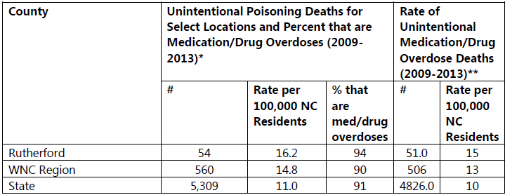

Source: NC State Center for Health Statistics and NC DPH

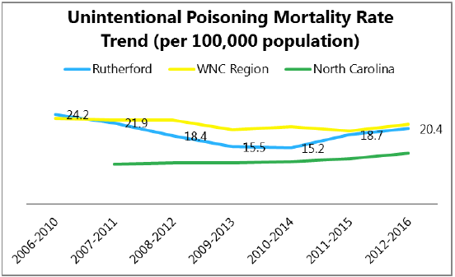

Source: NC State Center for Health Statistics and NC DPH

Moreover, substance abuse has adverse consequences for families, communities, and society. People who suffer from abuse or dependence are at risk for premature death, comorbid health conditions, injuries and disabilities. Over half, 54.8%, of Rutherford County residents indicated that their life has been negatively affected by substance abuse (by self or someone else) and 40.9% have experienced household substance abuse prior to age 18, an Adverse Childhood Experience (WNC Health Network, 2018). Both rates are significantly higher than that of the WNC region and the state.

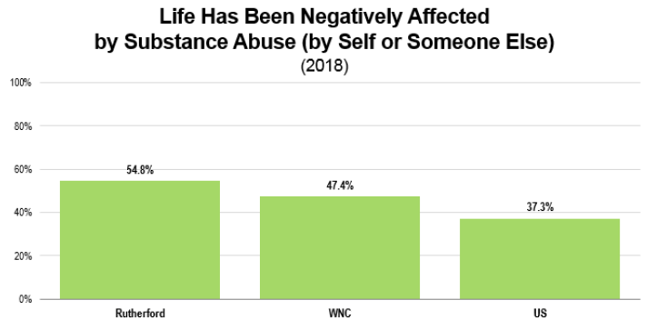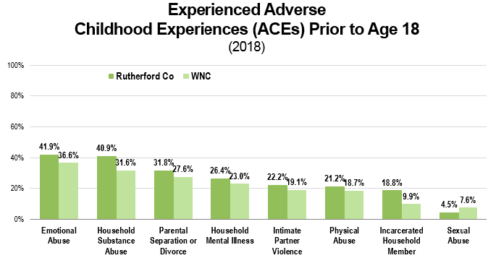

Source: WNC Healthy Impact Community Health Survey

The Centers for Disease Control and Prevention (CDC) explains that childhood experiences, both positive and negative, have a tremendous impact on future violence victimization and perpetration, and lifelong health and opportunity. Adverse Childhood Experiences (ACEs) are stressful or traumatic events including abuse, neglect and household dysfunction. ACEs have been linked to risky health behaviors, chronic health conditions, low life potential and early death. As the number of ACEs increases, so does the risk for these outcomes. For Rutherford County adults the prevalence of high ACE scores, meaning a score of 4 or more, is 23.1%. This is higher than that of the WNC region with a percentage of 15.9%.

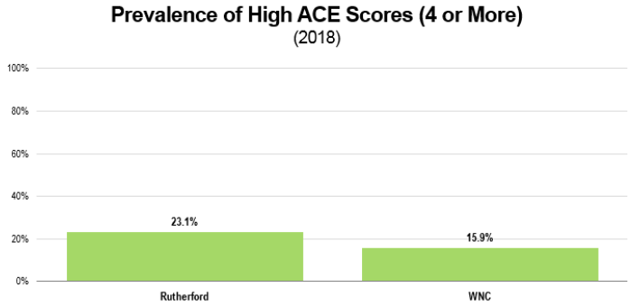

Source: WNC Healthy Impact Community Health Survey

Furthermore, 26.7% of Rutherford County adults have self-reported that they have used opiate/opioids in the past year, with or without a prescription. This rate is much higher than that of the WNC region, which rests at 19.6% (WNC Health Network, 2018). As of the 4th quarter in 2017, the year to date total of opioid pills dispensed to Rutherford County residents was 5,449,000 and as of the 1st quarter in 2018, there were 21 EMS naloxone administrations and 9 community naloxone reversals. Community naloxone reversals are reversals by community lay people not including administration by first responders (NC Opioid Action Plan Dashboard, 2018).

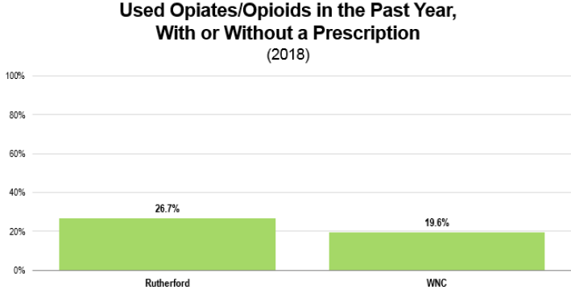

Source: WNC Healthy Impact Community Health Survey

While overdose and poisonings are significant in Rutherford County, other abused substances, such as tobacco, should not be ignored. Tobacco, like alcohol, is often the gateway to illicit drugs and can lead to unintentional injuries as they can inhibit the user’s faculties. In Rutherford County 20.2% of residents are current smokers, greater than the Healthy People 2020 target of 12% or lower. More residents in Rutherford county are smokers than that of the WNC region, the state and the country. Further, 10.9% of residents use smokeless tobacco – again, greater than the Healthy People 2020 target of 0.3% or lower, and significantly higher than that of all comparator jurisdictions. Also, the newer phenomena of e-cigarettes has reached a new height and currently 5.8% of Rutherford County residents are e-cigarette users. Finally, 18.3% of residents surveyed indicate that they have breathed someone else’s cigarette smoke at work in the past week (WNC Health Nework, 2018).

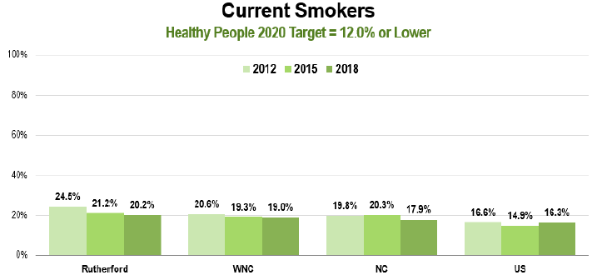 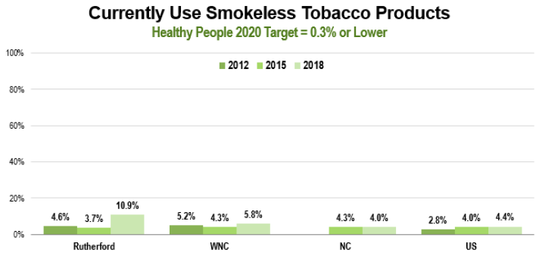

Source: WNC Healthy Impact Community Health Survey

### Community Input

There is great stigma surrounding substance abuse or misuse and addiction in Rutherford County. Residents are left not knowing where to access help and are unable to seamlessly integrate themselves back into their communities. One Community Leader indicated that many still view substance abuse as a “moral failure vs. a disease, and that can hamper efforts.” Another adds that in addition to the “stigma associated with getting treatment,” other impediments to this health issue are “difficulties in funding log-term residential programs” and the individual’s ability to find “housing and employment post-recovery” (WNCHN – Online Key Informant Survey, 2018).

Fortunately, this stigma is slowly being reduced as another community leader states that in Rutherford County, “we have a substance abuse problem; not just an opioid problem, but the community readiness to address the problems and engage in prevention and harm reduction is most beneficial.”

During the prioritization process, it was made evident that many prevention efforts that raise awareness and education, are already being implemented. A Rutherford County health provider explains that “we also need more treatment and resources; particularly on the recovery end of the spectrum. We need safe housing for people who are in treatment or post-treatment and need somewhere safe to stay and maintain their recovery. They wind up back in the same environment and that is detrimental to maintaining recovery.”

### What Else Do We Know?

Substance abuse refers to a set of related conditions associated with the consumption of mind and behavior-altering substances that have negative behavioral and health outcomes. Social attitudes and political and legal responses to the consumption of alcohol and illicit drugs make substance abuse one of the most complex public health issues.

The 5th leading cause of death in Rutherford County is “All other Unintentional Injuries,” with “all other” meaning not by motor vehicle. Unintentional injuries are injuries that are unplanned yet predictable and preventable when proper safety precautions are taken, such as poisonings and falls.

Young adults aged 18-25 years are more likely to report illicit drug use than people of other ages. Nearly one-third (30.7%) of Rutherford County’s population is made up of individuals aged 18-39 (WNC Health Network, 2018). In 2018, 9.7% of Rutherford County adults self-reported use of an illicit drug in the past month either by self or someone they know compared to 8.6% in the WNC region.

### What is Already Happening?

In August of 2017 a Medication Assisted Treatment (MAT) program was launched in the Rutherford County Jail to help those addicted to opioids. This program provides MAT, behavioral therapy, and wraparound services for Rutherford County jail inmates who are in a setting where traditionally they would be ineligible for funding to receive these types of services. The program features a one-year continuum of care that utilizes MAT and individual or group therapy during the incarceration period. Upon reentry to the community, participants will receive MAT, Substance Abuse Intensive Outpatient treatment, peer support services, and linkages to medical care as well as job skills and education support services. This program utilizes Vivitrol (naltrexone), a medication that blocks opiate cravings, in conjunction with behavioral therapy. While in jail, the cost of the medication is covered by grant funding provided by RHI Legacy Foundation and the participants do not pay any out of pocket costs for MAT.

Resulting from the Rutherford County Leadership Forum on Opioid and Substance abuse, a task force was formed that has taken on the lead in helping to find the best course of action to address substance abuse in the community. The task force is seeking strategies that can be implemented on a local level as well as looking at who potential partners in the community may be that can help move the work forward.

Under the leadership of the United Way of Rutherford County and its partnership with the Rutherford County Sherriff’s office, local grocery stores and fire departments, Operation Medicine Drop take back events are being held consistently throughout the year. These events provide a safe, convenient and responsible means of disposing of prescription drugs, while also educating the general public about the potential for abuse of medications.

### What Change Do We Want to See?

Substance use was ranked number one by community key informants as a health condition critical to address. Great accomplishments in this area would be to see a decrease in the misuse of substances and the use of tobacco. For example, in 2018, 26.7% of Rutherford County adults self-reported having used opiates/opioids in the past year with or without a prescription. Seeing this percentage decrease and possibly even fall below the WNC region percentage of 19.6% would indicate that the community is headed in the right direction. It would also suggest that more individuals are recognizing the dangers of prescription drugs.

Not only would a decrease in the use of substances demonstrate progress, but also a decrease in the use of tobacco. The percentage of Rutherford County adults who are current smokers is 20.2% meanwhile the Healthy People 2020 target is 12% or lower. A decrease in the Rutherford County rate, closer to 12%, would prove to be a great achievement.

Lastly, a paramount change would be to see the driving force behind this health priority come to fruition, which is for community members to have better access to substance abuse treatment and recovery resources. This would include Rutherford County’s own treatment and recovery program(s).

# 2016 Implementation Plan Impact

Rutherford Regional Health System adopted an implementation plan in 2016. The results are below.

|  |  |  |
| --- | --- | --- |
| Significant Health Need Identified in Preceding CHNA | Activities that Addressed Health Needs identified in Preceding Implementation Strategy | Results, Impact |
| Tobacco | Smoking cessations classes to employers | 3 on-site employer events |
| Smoking cessation certification obtained by CP Rehab staff members | Smoking Cessation Specialist visits 100% of all inpatients who ask for help |
| Lunch and Learns at RRHS to earn Vitality points | 20+ employees attended event and received Vitality Points |
| Increase utilization of "Radical Randy" in the school systems to help educate students on the dangers of tobacco | RRHS Cardiopulmonary Services coordinates program with local schools |
| Marketed smoking cessation program to local providers, practice managers and referral coordinators | local community is well aware of program currently have 20 enrolled individuals in the program |
| Chronic Disease | Held "Change 4 Life" Expo that unites all county resources together for one large-scale event aimed at promoting healthy living | 500 area citizens reached at Change 4 Life |
| Held quarterly Business Engagement Group (BEG) meetings to connect employers with RRHS programs and professionals who assist with managing chronic disease |  |
| Substance Abuse | Hosted a roundtable forum led by the RRHS psychiatrist, event included local law enforcement leaders and community activists | 50 area leaders and activists agree to hold regular meetings to collaborate |
| Participated in area health fairs and events (ex. Kids and Cops day) |  |

# For More Information and to Get Involved

For more information or to get involved please visit the Rutherford-Polk-McDowell Health District website at www.rpmhd.org/healthpromotion or contact the CHA facilitator via phone at (828) 287-6100.

# Appendices

Appendix A – Data Collection Methods & Limitations

Appendix B – Community Telephone Survey Findings

Appendix C – Key Informant Survey Findings

Appendix D – Community Asset Inventory

# Appendix A – Data Collection Methods & Limitations

Secondary Data from Regional Care

Secondary Data Methodology

In order to learn about the specific factors affecting the health and quality of life of residents of WNC, the WNC Healthy Impact data workgroup and data consulting team identified and tapped numerous secondary data sources accessible in the public domain For data on the demographic, economic and social characteristics of the region sources included: the US Census Bureau; Log Into North Carolina (LINC); NC Department of Health and Human Services; NC Office of State Budget and Management; NC Department of Commerce; Employment Security Commission of NC; UNC-CH Jordan Institute for Families; NC Department of Public Instruction; NC Department of Justice; NC Division of Medical Assistance; NC Department of Transportation; and the Cecil B. Sheps Center for Health Services Research. The WNC Healthy Impact data consultant team made every effort to obtain the most current data available at the time the report was prepared. It was not possible to continually update the data past a certain date; in most cases that end-point was August 2018.

The principal source of secondary health data for this report was the NC State Center for Health Statistics (NC SCHS), including its County Health Data Books, Behavioral Risk Factor Surveillance System, Vital Statistics unit, and Cancer Registry. Other health data sources included: NC Division of Public Health (DPH) Epidemiology Section; NC Division of Mental Health, Developmental Disabilities and Substance Abuse Services; the Centers for Disease Control and Prevention; National Center for Health Statistics; NC DPH Nutrition Services Branch; and NC DETECT.

Environmental data was gathered from sources including: US Environmental Protection Agency; US Department of Agriculture; and NC Department of Environment and Natural Resources.

Because in any CHA it is instructive to relate local data to similar data in other jurisdictions, throughout this report representative county data is compared to like data describing the 16-county region and the state of NC as a whole. The WNC regional comparison is used as “peer” for the purposes of this assessment. Where appropriate and available, trend data has been used to show changes in indicators over time.

It is important to note that this report contains data retrieved directly from sources in the public domain. In some cases, the data is very current; in other cases, while it may be the most current available, it may be several years old Note also that the names of organizations, facilities, geographic places, etc. presented in the tables and graphs in this report are quoted exactly as they appear in the source data. In some cases, these names may not be those in current or local usage; nevertheless, they are used so readers may track a particular piece of information directly back to the source.

**Gaps in Available Information**

While this assessment is quite comprehensive, it cannot measure all possible aspects of health in the community, nor can it adequately represent all possible populations of interest. It must be recognized that these information gaps might in some ways limit the ability to assess all of the community’s health needs.

In terms of content, this assessment was designed to provide a comprehensive and broad picture of the health of the overall community. However, there are certainly a great number of medical conditions that are not specifically addressed.

## WNC Healthy Impact Survey (Primary Data)

**Survey Methodology**

The 2018 WNC Healthy Impact Community Health Survey was conducted from March to June. The purpose of the survey was to collect primary data to supplement the secondary core dataset, allow individual counties in the region to collect data on specific issues of concern, and hear from community members about their concerns and priorities. The survey was conducted throughout the entire WNC Healthy Impact region, which includes the following 16 counties: Buncombe, Cherokee, Clay, Graham, Haywood, Henderson, Jackson, Macon, Madison, McDowell, Mitchell, Polk, Rutherford, Swain, Transylvania and Yancey.

Professional Research Consultants, Inc. (PRC) designed and implemented the survey methodology, which included a combination of telephone (both landline and cell phone) interviews, as well as an online survey. The survey methodology was designed to achieve a representative sample of the regional population that would allow for stratification by certain demographic characteristics, while also maximizing data collection timeliness and efficiency. Survey sampling and implementation methodology is described in greater detail below.

***Survey Instrument***

The survey instrument was developed by WNC Healthy Impact’s data workgroup, consulting team, and local partners, with assistance from PRC. Many of the questions were derived from the CDC Behavioral Risk Factor Surveillance System (BRFSS) and other validated public health surveys. Other questions were developed specifically by WNC Healthy Impact, with input from regional and local partners, to address particular issues of interest to communities in western North Carolina. Each county was given the opportunity to include three additional questions of particular interest to their county, which were asked only of their county’s residents.

The three additional county questions included in the 2018 survey were:

1. Do you currently have access to the internet for PERSONAL use, either at home, work, or school? (yes/no)
2. During the past 30 days, has someone you know used an illegal drug or taken a prescription drug that was not prescribed to them? (yes/no) During the past 30 days, has someone you know used an illegal drug or taken a prescription drug that was not prescribed to them? (yes/no)
3. How often in the past 12 months would you say you were worried or stressed about having enough money to buy nutritious meals? Would you say you were worried or stressed: Always, Usually, Sometimes, Seldom or Never?

***Sampling Approach & Design***

PRC designed the survey methodology to minimize sample bias and maximize representativeness by using best practice random-selection sampling techniques. They also used specific data analysis techniques, including poststratification, to further decrease sample bias and account for underrepresented groups or nonresponses in the population. Poststratification involves selecting demographic variables of interest within the population (here, gender, age, race, ethnicity, and poverty status) and then applying “weights” to the data to produce a sample which more closely matches the actual regional population for these characteristics. This technique preserves the integrity of each individual’s responses while improving overall representativeness. In order to determine WNC regional estimates, county responses were weighted in proportion to the actual population distribution to appropriately represent Western North Carolina as a whole. Since the sample design and quality control procedures used in the data collection ensure that the sample is representative, the findings may be generalized to the region with a high degree of confidence.

***Survey Administration***

PRC piloted the survey through 30 interviews across the region and consulted with WNC Health Network staff to resolve substantive issues before full implementation. PRC used trained, live interviewers and an automated computer-aided telephone interviewing system to administer the survey region-wide. Survey interviews were conducted primarily during evening and weekend hours, with some daytime weekday attempts. Interviewers made up to five call attempts per telephone number. Interviews were conducted in either English or Spanish, as preferred by respondents. The final sample included 29 percent cell phone-based survey respondents and 71 percent landline-based survey respondents. Including cell phone numbers in the sampling algorithm allowed better representation of demographic segments that might otherwise be under sampled in a landline-only model.

PRC also worked with a third-party provider to identify and invite potential respondents for an online survey for a small proportion (20%) of the sample population. The online survey was identical to the telephone survey instrument and allowed better sampling of younger and more urban demographic segments.

**About the Rutherford County Sample**

Size: The total regional sample size was 3,265 individuals age 18 and older, with 200 from our county. PRC conducted all analysis of the final, raw dataset.

Sampling Error: For our county-level findings, the maximum error rate at the 95% confidence level is +6.9%.

Expected Error Ranges for a Sample of 200 Respondents at the 95 Percent Level of Confidence

Note: The "response rate" (the percentage of a population giving a particular response) determines the error rate associated with that response. A "95 percent level of confidence" indicates that responses would fall within the expected error range on 95 out of 100 trials.

Examples:

* If 10% of a sample of 200 respondents answered a certain question with a "yes," it can be asserted that between 5.8% and 14.2% (10% ± 4.2%) of the total population would offer this response.
* If 50% of respondents said "yes," one could be certain with a 95 percent level of confidence that between 43.1% and 56.9% (50% ± 6.9%) of the total population would respond "yes" if asked this question.

**Benchmark Data**

***North Carolina Risk Factor Data***

Statewide risk factor data are provided where available as an additional benchmark against which to compare local survey findings; these data are reported in the most recent BRFSS (Behavioral Risk Factor Surveillance System) Prevalence and Trend Data published by the Centers for Disease Control and Prevention and the US Department of Health & Human Services.

***Nationwide Risk Factor Data***

Nationwide risk factor data, which are also provided in comparison charts where available, are taken from the 2017 PRC National Health Survey; the methodological approach for the national study is identical to that employed in this assessment, and these data may be generalized to the US population with a high degree of confidence.

***Healthy People 2020***

Healthy People provides science-based, 10-year national objectives for improving the health of all Americans. The Healthy People initiative is grounded in the principle that setting national objectives and monitoring progress can motivate action. For three decades, Healthy People has established benchmarks and monitored progress over time in order to:

•Encourage collaborations across sectors.

•Guide individuals toward making informed health decisions.

•Measure the impact of prevention activities.

Healthy People 2020 is the product of an extensive stakeholder feedback process that is unparalleled in government and health. It integrates input from public health and prevention experts, a wide range of federal, state and local government officials, a consortium of more than 2,000 organizations, and perhaps most importantly, the public. More than 8,000 comments were considered in drafting a comprehensive set of Healthy People 2020 objectives.

**Information Gaps**

While this assessment is quite comprehensive, it cannot measure all possible aspects of health in the community, nor can it adequately represent all possible populations of interest. It must be recognized that these information gaps might in some ways limit the ability to assess all of the community’s health needs.

For example, certain population groups (such as the homeless, institutionalized persons, or those who only speak a language other than English or Spanish) are not represented in the survey data. Other population groups (for example, pregnant women, lesbian/gay/bisexual/transgender residents, undocumented residents, and members of certain racial/ethnic or immigrant groups) might not be identifiable or might not be represented in numbers sufficient for independent analyses.

In terms of content, this assessment was designed to provide a comprehensive and broad picture of the health of the overall community. However, there are certainly a great number of medical conditions that are not specifically addressed.

## Online Key Informant Survey (Primary Data)

**Online Survey Methodology**

Purpose and Survey Administration

WNC Healthy Impact, with support from PRC, implemented an Online Key Informant Survey to solicit input from local leaders and stakeholders who have a broad interest in the health of the community. WNC Healthy Impact shared with PRC a list of recommended participants, including those from our county. This list included names and contact information for physicians, public health representatives, other health professionals, social service providers, and a variety of other community leaders. Potential participants were chosen because of their ability to identify primary concerns of the populations with whom they work, as well as of the community overall.

Key informants were contacted through an email that introduced the purpose of the survey and provided a link to take the survey online. Reminder emails were sent as needed to increase participation.

***Online Survey instrument***

The survey provided respondents the opportunity to identify critical health issues in their community, the feasibility of collaborative efforts around health issues, and what is helping/hurting their community’s ability to make progress on health issues.

***Participation***

In all, 18 community stakeholders took part in the Online Key Informant Survey for our county, as outlined below:

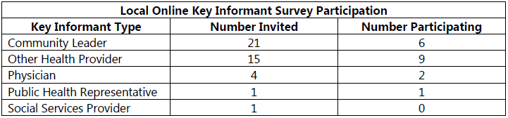

Through this process, input was gathered from several individuals whose organizations work with low-income, minority populations, or other medically underserved populations.

***Online Survey Limitations***

The Online Key Informant Survey was designed to gather input from participants regarding their opinions and perceptions of the health of the residents in the area. Thus, these findings are based on perceptions, not facts.

To collect this data, purposive sampling (a type of non-probability sampling which targets a specific group of people) was used. Unlike the random sampling technique employed in the telephone survey, the purpose is not to make generalizations or statistical inferences from the sample to the entire population, but to gather in-depth insights into health issues from a group of individuals with a specific perspective.

## Data Definitions

Reports of this type customarily employ a range of technical terms, some of which may be unfamiliar to many readers. Health data, which composes a large proportion of the information included in this report, employs a series of very specific terms which are important to interpreting the significance of the data. While these technical health data terms are defined in the report at the appropriate time, there are some data caveats that should be applied from the onset.

***Error***

First, readers should note that there is some error associated with every health data source. Surveillance systems for communicable diseases and cancer diagnoses, for instance, rely on reports submitted by health care facilities across the state and are likely to miss a small number of cases, and mortality statistics are dependent on the primary cause of death listed on death certificates without consideration of co-occurring conditions.

***Age-adjusting***

Secondly, since much of the information included in this report relies on mortality data, it is important to recognize that many factors can affect the risk of death, including race, gender, occupation, education and income. The most significant factor is age, because an individual’s risk of death inevitably increases with age. As a population ages, its collective risk of death increases; therefore, an older population will automatically have a higher overall death rate just because of its age distribution. At any one time some communities have higher proportions of “young” people, and other communities have a higher proportion of “old” people. In order to compare mortality data from one community with the same kind of data from another, it is necessary first to control for differences in the age composition of the communities being compared. This is accomplished by age-adjusting the data.

Age-adjustment is a statistical manipulation usually performed by the professionals responsible for collecting and cataloging health data, such as the staff of the NC State Center for Health Statistics (NC SCHS). It is not necessary to understand the nuances of age-adjustment to use this report. Suffice it to know that age-adjusted data are preferred for comparing most health data from one population or community to another and have been used in this report whenever available.

***Rates***

Thirdly, it is most useful to use rates of occurrence to compare data. A rate converts a raw count of events (deaths, births, disease or accident occurrences, etc.) in a target population to a ratio representing the number of same events in a standard population, which removes the variability associated with the size of the sample. Each rate has its own standard denominator that must be specified (e.g., 1,000 women, 100,000 persons, 10,000 people in a particular age group, etc.) for that rate.

While rates help make data comparable, it should be noted that small numbers of events tend to yield rates that are highly unstable, since a small change in the raw count may translate to a large change in rate. To overcome rate instability, another convention typically used in the presentation of health statistics is data aggregation, which involves combining like data gathered over a multi-year period, usually three or five years. The practice of presenting data that are aggregated avoids the instability typically associated with using highly variable year-by-year data, especially for measures consisting of relatively few cases or events. The calculation is performed by dividing the sum number of cases or deaths in a population due to a particular cause over a period of years by the sum of the population size for each of the years in the same period.

Health data for multiple years or multiple aggregate periods is included in this report wherever possible. Sometimes, however, even aggregating data is not sufficient, so the NC SCHS recommends that rates based on fewer than 20 events—whether covering an aggregate period or not—be considered unstable. In fact, in some of its data sets the NC SCHS no longer calculates rates based on fewer than 20 events. To be sure that unstable data do not become the basis for local decision-making, this report will highlight and discuss primarily rates based on 20 or more events in a five-year aggregate period, or 10 or more events in a single year. Where exceptions occur, the text will highlight the potential instability of the rate being discussed.

***Regional arithmetic mean***

Fourthly, sometimes in order to develop a representative regional composite figure from sixteen separate county measures the consultants calculated a regional arithmetic mean by summing the available individual county measures and dividing by the number of counties providing those measures. It must be noted that when regional arithmetic means are calculated from rates the mean is not the same as a true average rate but rather an approximation of it. This is because most rates used in this report are age adjusted, and the regional mean cannot be properly age-adjusted.

***Describing difference and change***

Fifthly, in describing differences in data of the same type from two populations or locations, or changes over time in the same kind of data from one population or location—both of which appear frequently in this report—it is useful to apply the concept of percent difference or change. While it is always possible to describe difference or change by the simple subtraction of a smaller number from a larger number, the result often is inadequate for describing and understanding the scope or significance of the difference or change. Converting the amount of difference or change to a percent takes into account the relative size of the numbers that are changing in a way that simple subtraction does not and makes it easier to grasp the meaning of the change.

For example, there may be a rate of for a type of event (e.g., death) that is one number one year and another number five years later. Suppose the earlier figure is 12.0 and the latter figure is 18.0. The simple mathematical difference between these rates is 6.0. Suppose also there is another set of rates that are 212.0 in one year and 218.0 five years later.The simple mathematical difference between these rates also is 6.0. But are these same simple numerical differences really of the same significance in both instances? In the first example, converting the 6-point difference to a percent yields a relative change factor of 50%; that is, the smaller number increased by half, a large fraction. In the second example, converting the 6-point difference to a percent yields a relative change factor of 2.8%; that is, the smaller number increased by a relatively small fraction. In these examples the application of percent makes it very clear that the difference in the first example is of far greater degree than the difference in the second example. This document uses percentage almost exclusively to describe and highlight degrees of difference and change, both positive (e.g., increase, larger than, etc.) and negative (e.g., decrease, smaller than, etc.).

**Data limitations**

Some data that is used in this report may have inherent limitations, due to the sample size, its geographic focus, or its being out-of-date, for example, but it is used nevertheless because there is no better alternative. Whenever this kind of data is used, it will be accompanied by a warning about its limitations.

# Appendix B – WNC Healthy Impact Community Survey (Primary Data)

In March to June 2018, 200 community members were surveyed randomly via telephone both landline and cell phones and online surveys. They survey instrument was developed by WNC Healthy Impact’s data workgroup, consulting team and local partners with assistance from Professional Research Corporation (PRC). Many of the questions were derived from the Centers for Disease Control and Prevention (CDC) Behavioral Risk Factor Surveillance System (BRFSS) as well as other public health surveys. For the county-level results, the maximum error rate at the 95% confidence level is +/- 6.9%.

Characteristics: The following chart outlines the characteristics of the survey sample for our county by key demographic variables, compared to actual population characteristics from census data. Note that the sample consists solely of area residents age 18 and older.

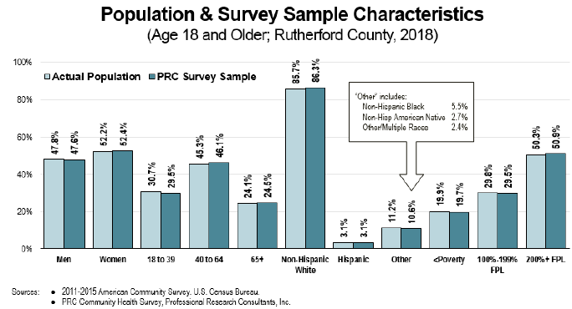

|  |  |  |  |
| --- | --- | --- | --- |
| *% experience “fair” or “poor health* | 2012 | 2015 | 2018 |
| Rutherford County | 22.2% | 17.7% | 25.3% |
| Western NC | 19.0% | 17.3% | 17.3% |
| North Carolina | 18.1% | 19.2% | 18.3% |
| US | 16.8% | 15.3% | 18.1% |

|  |  |  |  |
| --- | --- | --- | --- |
| *% limited in activities in some way due to a physical, mental or emotional problem* | 2012 | 2015 | 2018 |
| Rutherford County | 25.0% | 32.6% | 38.7% |
| Western NC | 28.1% | 28.1% | 30.7% |
| North Carolina | 21.2% | 21.2% | 21.6% |
| US | 17.0% | 21.5% | 25.0% |

|  |  |  |  |  |
| --- | --- | --- | --- | --- |
| *Type of problem that limits activities:* | Rutherford County | | Western NC | |
|  | **2015** | **2018** | **2015** | **2018** |
| Back/neck problem | 13.4% | 15.0% | 18.6% | 17.0% |
| Arthritis/rheumatism | 17.9% | 14.2% | 15.9% | 12.9% |
| Difficulty walking | 11.9% | 5.3% | 9.7% | 7.2% |
| Fracture bone/joint injury | 4.5% | 4.8% | 6.8% | 5.5% |
| Lung/breathing problem | 6.0% | 6.4% | 4.4% | 4.0% |
| Mental/depression | 4.5% | 26.3% | 3.3% | 15.0% |
| Heart problem | 3.0% |  | 3.0% |  |
| Other (each <3%) | 38.8% | 28% | 38.3% | 38.4% |

|  |  |  |  |
| --- | --- | --- | --- |
| *>7 days poor mental health in the past month* | 2012 | 2015 | 2018 |
| Rutherford County | 17.7% | 16.2% | 23.7% |
| Western NC | 14.2% | 13.0% | 18.7% |

|  |  |  |  |
| --- | --- | --- | --- |
| *“Always” or “Usually” get needed social/emotional support* | 2012 | 2015 | 2018 |
| Rutherford County | 75.5% | 82.0% | 66.8% |
| Western NC | 80.6% | 79.3% | 75.3% |

|  |  |  |  |
| --- | --- | --- | --- |
| *Unable to get needed mental health care or counseling in the past year* | 2012 | 2015 | 2018 |
| Rutherford County | 7.1% | 8.9% | 14.8% |
| Western NC | 6.6% | 7.5% | 12.3% |

|  |  |  |  |
| --- | --- | --- | --- |
| *Dissatisfied with Life (% dissatisfied or very dissatisfied)* | 2012 | 2015 | 2018 |
| Rutherford County | 4.3% | 6.4% | 18.5% |
| Western NC | 5.0% | 5.4% | 10.5% |

|  |  |  |  |  |
| --- | --- | --- | --- | --- |
|  | *Prevalence of Heart Disease* | | *Prevalence of Stroke* | |
|  | **2015** | **2018** | **2015** | **2018** |
| Rutherford County | 8.8% | 11.2% | 2.8% | 3.4% |
| Western NC | 6.5% | 8.0% | 3.9% | 4.3% |
| NC |  |  | 3.7% | 3.9% |
| US | 6.1% | 8.0% | 3.9% | 4.7% |

|  |  |  |  |  |  |  |  |  |
| --- | --- | --- | --- | --- | --- | --- | --- | --- |
|  | *Have had blood pressure checked in the past two years* | | *Prevalence of high blood pressure* | | | *Taking action to control high blood pressure (among adults with HBP)* | | |
|  | **2012** | **2015** | **2012** | **2015** | **2018** | **2012** | **2015** | **2018** |
| Rutherford Co | 93.2% | 92.0% | 45.7% | 47.6% | 45.1% | 88.4% | 95.2% | 92.1% |
| Western NC | 95.0% | 94.8% | 39.4% | 38.1% | 39.2% | 91.2% | 92.4% | 91.3% |
| NC |  |  | 31.5% | 35.5% | 35.2% |  |  |  |
| US | 94.7% | 91.0% | 34.3% | 34.1% | 37.0% | 89.1% | 89.2% | 93.8% |

|  |  |  |  |  |  |  |
| --- | --- | --- | --- | --- | --- | --- |
|  | *Prevalence of high blood cholesterol* | | | *Taking action to control high blood cholesterol (among adults with HBC)* | | |
|  | **2012** | **2015** | **2018** | **2012** | **2015** | **2018** |
| Rutherford Co | 38.9% | 35.3% | 42.7% | 87.8% | 89.1% | 89.4% |
| Western NC | 34.3% | 31.2% | 33.8% | 88.8% | 88.2% | 87.0% |
| NC | 40.0% | 41.0% |  |  |  |  |
| US | 31.4% | 29.9% | 36.2% | 89.1% | 81.4% | 87.3% |

|  |  |  |
| --- | --- | --- |
| *Have fallen in the past year (seniors age 65+)* | 2012 | 2015 |
| Rutherford County | 27.7% | 37.6% |
| Western NC | 25.2% | 33.0% |

|  |  |  |  |  |  |  |  |  |
| --- | --- | --- | --- | --- | --- | --- | --- | --- |
|  | *Prevalence of diabetes (ever diagnosed)* | | | *Prevalence of borderline or pre-diabetes* | | | *Tested for diabetes in the past three years (among adults Not diagnosed with diabetes)* | |
|  | **2012** | **2015** | **2018** | **2012** | **2015** | **2018** | **2012** | **2015** |
| Rutherford Co | 15.1% | 10.2% | 20.3% | 7.9% | 14.7% | 8.8% | 51.6% | 57.1% |
| Western NC | 12.6% | 7.5% | 14.4% | 7.6% | 12.2% | 7.5% | 55.6% | 62.3% |
| NC | 9.8% | 11.4% | 11.3% |  |  |  |  |  |
| US | 10.1% | 11.7% | 13.3% |  | 5.8% | 9.5% |  | 49.2% |

|  |  |  |
| --- | --- | --- |
| *Taken action to control diabetes (among adults diagnosed with diabetes or prediabetes/ borderline diabetes* | 2012 | 2015 |
| Rutherford County | 91.2% | 61.7% |
| Western NC | 87.7% | 64.3% |

|  |  |  |  |  |
| --- | --- | --- | --- | --- |
|  | *Current prevalence of Asthma* | | *Prevalence of Chronic Obstructive Pulmonary Disease (COPD)* | |
|  | **2015** | **2018** | **2015** | **2018** |
| Rutherford Co | 14.9% | 19.0% | 12.9% | 14.9% |
| Western NC | 9.7% | 11.4% | 13.5% | 13.9% |
| NC | 8.4% | 8.0% | 7.4% | 7.3% |
| US | 9.4% | 11.8% | 8.6% | 8.6% |

|  |  |  |  |
| --- | --- | --- | --- |
|  | *Strengthening physical activity* | | |
|  | **2012** | **2015** | **2018** |
| Rutherford County | 37.2% | 28.0% | 25.8% |
| Western NC | 35.1% | 34.6% | 31.9% |
| NC |  |  | 29.3% |
| US |  |  | 33.8%% |

|  |  |  |  |  |  |  |  |  |
| --- | --- | --- | --- | --- | --- | --- | --- | --- |
|  | *Meets physical activity recommendations* | | | *Believe it is important that community orgs make physical activity spaces available for public use after hours* | | *Healthy weight (body mass index between 18.5 and 24.9)* | | |
|  | **2012** | **2015** | **2018** | **2012** | **2015** | **2012** | **2015** | **2018** |
| Rutherford County | 53.1% | 49.8% | 16.5% | 92.8% | 89.9% | 24.8% | 24.8% | 21.6% |
| Western NC | 58.2% | 53.5% | 21.3% | 95.6% | 94.1% | 33.7% | 33.5% | 31.5% |
| NC |  |  | 18.9% |  |  |  |  | 31.4% |
| US | 42.7% | 50.3% | 22.8% |  |  | 31.7% | 34.4% | 30.3% |

|  |  |  |  |  |  |  |  |  |  |
| --- | --- | --- | --- | --- | --- | --- | --- | --- | --- |
|  | *Prevalence of total overweight (overweight or obese BMI of 25.0 or higher)* | | | *Obesity (body mass index of 30.0 or higher)* | | | *No leisure-time physical activity in the past month* | | |
|  | **2012** | **2015** | **2018** | **2012** | **2015** | **2018** | **2012** | **2015** | **2018** | |
| Rutherford County | 74.1% | 73.9% | 77.1% | 35.2% | 33.1% | 49.8% | 20.8% | 23.5% | 30.1% | |
| Western NC | 65.0% | 64.3% | 66.8% | 29.2% | 28.8% | 31.9% | 15.9% | 19.2% | 25.0% | |
| NC | 65.3% | 66.1% | 66.9% | 28.6% | 29.4% | 31.8% | 25.7% | 26.6% | 23.3% | |
| US | 66.9% | 63.1% | 67.8% | 28.5% | 29.0% | 32.8% | 28.7% | 20.7% | 26.2% | |

|  |  |  |  |  |  |  |
| --- | --- | --- | --- | --- | --- | --- |
|  | *Binge Drinkers* | | | *Current Drinkers* | | |
|  | **2012** | **2015** | **2018** | **2012** | **2015** | **2018** |
| Rutherford County | 12.1% | 9.1% | 9.5% | 32.6% | 32.7% | 39.6% |
| Western NC | 10.6% | 10.0% | 12.3% | 42.9% | 43.7% | 45.8% |
| NC | 11.0% | 13.0% | 14.6% | 44.1% | 44.3% | 49.1% |
| US | 16.7% | 19.5% | 20.0% | 58.8% | 56.5% | 55.0% |

|  |  |  |
| --- | --- | --- |
|  | *Excessive Drinkers* | |
|  | **2015** | **2018** |
| Rutherford County | 11.9% | 12.3% |
| Western NC | 15.4% | 15.7% |
| NC | 23.2% | 22.5% |

|  |  |  |
| --- | --- | --- |
| *2018* | *Used opiates/opioids in the past year, with or without a prescription* | *Life has been negatively affected by substance abuse 9by self or someone else)* |
| Rutherford County | 26.7% | 54.8% |
| Western NC | 19.6% | 47.4% |
| US |  | 37.3% |

|  |  |
| --- | --- |
| *2018* | *Used an illicit drug in the past month (self or known)* |
| Rutherford County | 9.7% |
| Western NC | 8.6% |

|  |  |  |  |  |  |  |  |  |  |
| --- | --- | --- | --- | --- | --- | --- | --- | --- | --- |
|  | *Current smokers* | | | *Currently use smokeless tobacco products* | | | *Have breathed someone else’s cigarette smoke at work in the past week (among employed respondents)* | | |
|  | **2012** | **2015** | **2018** | **2012** | **2015** | **2018** | **2012** | **2015** | **2018** |
| Rutherford County | 24.5% | 21.2% | 20.2% | 4.6% | 3.7% | 10.9% | 19.6% | 13.7% | 18.3% |
| Western NC | 20.6% | 19.3% | 19.0% | 5.2% | 4.3% | 5.8% | 14.2% | 14.2% | 17.0% |
| NC | 19.8% | 20.3% | 17.9% |  | 4.3% | 4.0% |  |  |  |
| US | 16.6% | 14.9% | 16.3% | 2.8% | 4.0% | 4.4% |  |  |  |

|  |  |  |
| --- | --- | --- |
|  | *Currently Use Vaping Products (such as E-Cigarettes)* | |
|  | **2015** | **2018** |
| Rutherford County | 4.9% | 5.8% |
| Western NC | 6.6% | 7.2% |
| NC |  | 4.4% |
| US | ` | 3.8% |

|  |  |  |  |
| --- | --- | --- | --- |
| *Consume five or more servings of fruits/vegetables per day* | 2012 | 2015 | 2018 |
| Rutherford County | 10.8% | 3.3% | 7.0% |
| Western NC | 8.0% | 8.1% | 6.5% |

|  |  |
| --- | --- |
| *2018* | *Food insecurity* |
| Rutherford County | 33.7% |
| Western NC | 23.8% |
| US | 27.9% |

|  |  |  |
| --- | --- | --- |
| *Experienced adverse childhood experiences (ACEs) prior to age 18 (2018)* | Rutherford County | Western NC |
| Emotional Abuse | 41.9% | 36.6% |
| Household Substance Abuse | 40.9% | 31.6% |
| Parental Separation or Divorce | 31.8% | 27.6% |
| Household Mental Illness | 18.6% | 16.1% |
| Intimate Partner Violence | 48.6% | 49.2% |
| Physical Abuse | 21.2% | 18.7% |
| Incarcerated Household member | 18.8% | 9.9% |
| Sexual Abuse | 4.5% | 7.6% |

|  |  |
| --- | --- |
| *2018* | *Prevalence of high ACE Scores (4 or more)* |
| Rutherford County | 23.1% |
| Western NC | 15.9% |

|  |  |  |  |  |  |  |  |  |  |
| --- | --- | --- | --- | --- | --- | --- | --- | --- | --- |
|  | *Lack of healthcare insurance coverage (adults age 18-64)* | | | *Was unable to get needed medical care at some point in the past year* | | | *Have visited a physician for a checkup in the past year* | | |
|  | **2012** | **2015** | **2018** | **2012** | **2015** | **2018** | **2012** | **2015** | **2018** |
| Rutherford County | 31.4% | 18.1% | 13.3% | 16.0% | 8.6% | 15.1% | 77.1% | 79.2% | 77.9% |
| Western NC | 23.7% | 19.6% | 19.8% | 10.8% | 9.1% | 12.4% | 72.4% | 71.1% | 73.3% |
| NC | 17.7% | 24.2% | 17.1% |  |  |  |  | 73.2% | 74.6% |
| US | 14.9% | 15.1% | 13.7% |  |  |  | 67.3% | 65.0% | 68.3% |

|  |  |  |  |  |  |  |  |
| --- | --- | --- | --- | --- | --- | --- | --- |
|  | *Have visited a dentist or dental clinic in the past year* | | | *Have had a mammogram in the past two years (women age 50-74)* | | *Have a specific source of ongoing medical Care* | |
|  | **2012** | **2015** | **2018** | **2015** | **2018** | **2015** | **2018** |
| Rutherford County | 57.6% | 55.8% | 52.2% | 77.5% | 78.5% | 82.6% | 83.6% |
| Western NC | 63.7% | 63.7% | 61.6% | 77.7% | 78.7% | 82.3% | 80.9% |
| NC | 68.4% | 64.9% | 63.6% | 79.4% | 79.3% | 76.3% | 74.1% |
| US | 66.9% | 65.9% | 59.7% | 83.6% | 77.0% |  |  |

|  |  |
| --- | --- |
| *2018* | *Have access to the internet or personal use at home, work or school (Rutherford County)* |
| Yes | 79.9% |
| No | 20.1% |

|  |  |  |  |
| --- | --- | --- | --- |
| *Frequency of worry/stress in the past year about having enough money to buy nutritious meals (Rutherford County)* | 2012 | 2015 | 2018 |
| Always | 8.5% | 8.6% | 4.9% |
| Usually | 6.1% | 5.6% | 10.2% |
| Sometimes | 18.2% | 20.5% | 17.4% |
| Seldom | 18.6% | 16.1% | 10.7% |
| Never | 48.6% | 49.2% | 56.8% |

# Appendix C - Key Informant Survey Results (Primary Data)

Eighteen key informants were asked about the health in the community. In the online survey, key informants were asked to list characteristics of a healthy community. They were also asked to select the health issues or behaviors that they feel are the most critical to address collaboratively in their own community over the next three years or more. Follow-up questions asked them to describe which contributors to progress and impediments of progress exist for these issues. Results of their ratings, as well as their verbatim comments, are included throughout this report.

Key informants characterized a healthy community as containing the following (percentages represent the proportion of respondents identifying each characteristic as one of their top 3 responses):

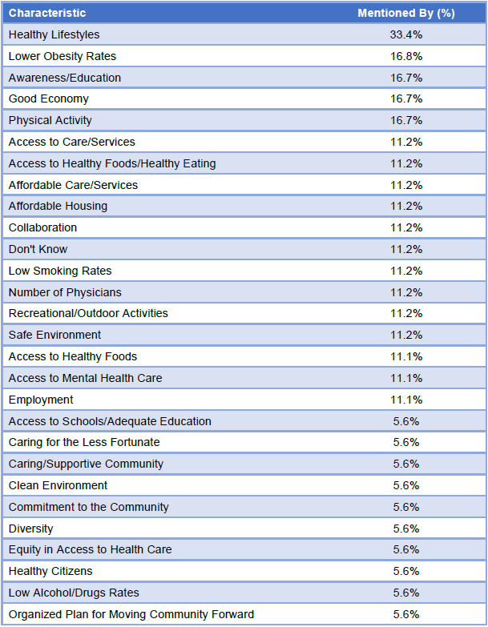

### Chronic Disease

Ranking of Chronic Disease Issues as Critical to Address

Key informants in the online survey were given a list of chronic diseases and known factors that contribute to them, then asked to select up to three health issues or behaviors that are the most critical to address collaboratively in their community over the next three years or more.

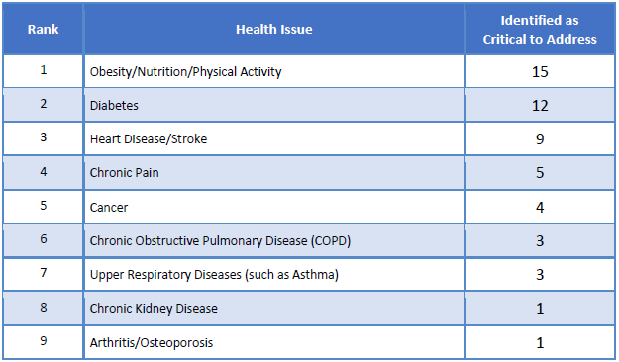

#### Nutrition, and Physical Activity

**Contributors to Progress**

Those identifying this as a critical issue were asked: “What is contributing to progress on this issue in your community?”

*Recreational/Outdoor Activities*

* The excitement surrounding the Rail Trail. This can be a game changer for our county if that becomes as popular as it is in other communities. The 5-2-1 none campaign is also a fantastic tool for our youth and families. – Community Leader (Rutherford County)
* The completion of our 13.8-mile thermal rail trail is making outdoor exercise more interesting and accessible. More established walking trails throughout the county. – Community Leader (Rutherford County)
* The Rails to Trails project will give the majority of the community a resource for exercise with very little individual investment. Programs such as Walk with a Doc. – Other Health Provider (Rutherford County)
* Greenways, Rail Trail, Bike Plans, Recreation areas and promotion of all these. Food Network and work toward Food Policy Council. Health department has hired a local food coordinator. This is very good. – Other Health Provider (Rutherford County)
* Walking trails, education in school. – Physician (Rutherford County)
* The new bike and hiking trail may have a positive effect if people are informed and access is facilitated. If people begin to realize that walking and biking are viable forms of transport, maybe they will start. – Other Health Provider (Rutherford County)

*Awareness/Education*

* Educational campaigns such as “5-2-1 Almost None" have gained some traction, and we also have a school health committee, as well as our Community Health Council that are focused on all of these areas. – Community Leader (Rutherford County)
* Free education programs. – Other Health Provider (Rutherford County)

*Specific Programs/Agencies*

* The Rutherford Community Health Council sponsors many events promoting healthy activity/exercise, as well as food security. Strong Parks and Recreation program. – Other Health Provider (Rutherford County)
* Cooperative Extension. – Other Health Provider (Rutherford County)

*Collaborative Efforts*

* Many agencies working together toward common goal. – Community Leader (Rutherford County)

*Physical Activity*

* Availability of options to get exercise as a family and better options of healthy eating. I hope that fast food joints listing calories per meal on menus is helping people understand what they are eating. – Community Leader (Rutherford County)

**Impediments of Progress**

Those identifying this as a critical issue were asked: “What is getting in the way of progress on this issue in your community?”

*Lifestyle*

* Individuals who have sedentary lifestyles and poor nutrition. Generational obesity. Lack of daily recess/gym for school-aged children/youth. Healthy foods are more expensive. – Other Health Provider (Rutherford County)
* People make poor choices in food and don’t exercise. Transportation is a barrier. – Other Health Provider (Rutherford County)
* Food ignorance, sedentary lifestyles, garbage food. Unwillingness to cook and eat right. Not many outlets for safe, convenient outdoor physical activity. There is a fat person epidemic here in Rutherford County. – Other Health Provider (Rutherford County)
* Personal health choices. Economic status. – Other Health Provider (Rutherford County)

*Awareness/Education*

* Basically, just making sure that all levels of our community know about what's available. – Community Leader (Rutherford County)
* Lack of consumer knowledge about nutrition and lack of motivation to change lifestyle behaviors. – Community Leader (Rutherford County)

*Denial*

* Laziness of people. Technology leads people to play on their phones and games while staying inside and glued to the TV. – Community Leader (Rutherford County)
* Lack of motivation and resources for families but things are improving. – Community Leader (Rutherford County)
* A lack of desire on the part of the majority of citizens. We need to push harder for state-funded benefits to require certain criteria in health management in order for someone to qualify for the benefits. – Physician (Rutherford County)

*Built Environment*

* Lack of safe places to exercise if you don't belong to a gym (rural roads, or areas with no sidewalks/lighting) and the social norms of unhealthy fast food. – Community Leader (Rutherford County)

*Lack of Prevention for Youth*

* More schools should adopt policies for increase physical activity and continue to make changes to school menus. Take vending machines out of schools and do not allow children to sell candy and other foods that are not nutritious. Change menu at sporting event concession stands. – Other Health Provider (Rutherford County)

*Poverty*

* Poor economy, poor nutrition, inactive people. – Physician (Rutherford County)

*Transportation*

* Transportation to programs. – Other Health Provider (Rutherford County)

#### Diabetes

**Contributors to Progress**

Those identifying this as a critical issue were asked: “What is contributing to progress on this issue in your community?”

*Awareness/Education*

* Diabetes awareness, education and interventions. Access to fresh produce. – Other Health Provider (Rutherford County)
* The awareness that there are ways to manage diabetes. There are several organizations that are working to create a better way to manage this chronic disease. – Other Health Provider (Rutherford County)
* Educators and programs are available. – Community Leader (Rutherford County)

*Access to Care/Services*

* More events to address those issues that are free to the public and are marketed appropriately. – Community Leader (Rutherford County)

*Nothing/No Progress*

* Unhealthy eating habits. – Other Health Provider (Rutherford County)

*Affordable Care/Services*

* Medication assistance program at the community clinic. – Physician (Rutherford County)

*Community Focus*

* More input from community and more funds for correcting these problems. – Community Leader (Rutherford County)

*Built Environment*

* I believe the work the Community Health Council is doing around chronic disease issues will help make additional progress in this area if those initiatives 'catch on.' I think the rail trail will help with the exercise component in a major way. If we could convince the towns to plant some 'community' fruit trees along the way for healthy snacks... you see where that thought is going. – Community Leader (Rutherford County)
* Walking trails. – Physician (Rutherford County)

**Impediments of Progress**

Those identifying this as a critical issue were asked: “What is getting in the way of progress on this issue in your community?”

*Access to Healthy Food*

* Healthy food choices for some of the residents of the county are limited due to income restrictions. Some residents are not willing to commit to a lifestyle change to improve their own health status. – Other Health Provider (Rutherford County)
* A number of factors, including: cost of processed, unhealthy foods vs healthier fresh foods; proliferation of fast food restaurants; and the fact that many people live in areas with no sidewalks/unsafe conditions to just get out and walk. – Community Leader (Rutherford County)
* Poor economic area contributes to poor nutrition. – Physician (Rutherford County)

*Lifestyle*

* People don't want to give up their sweet tea and fried food. – Other Health Provider (Rutherford County)

*Awareness/Education*

* I believe we need more discussion for our children and youth about the health concerns and risk and educating them away from drug use and [toward] healthy choices. – Community Leader (Rutherford County)
* Lack of awareness about the disease and its complications. – Community Leader (Rutherford County)
* Education of public. – Community Leader (Rutherford County)

*Disease Management*

* Noncompliance. – Physician (Rutherford County)

*Transportation*

* Transportation to programs. – Other Health Provider (Rutherford County)

*Insufficient Physical Activity*

* There is not a YMCA in Rutherford County. The YMCA is leading efforts to reduce diabetes in neighboring counties. – Other Health Provider (Rutherford County)

#### Heart Disease and Stroke

**Contributors to Progress**

Those identifying this as a critical issue were asked: “What is contributing to progress on this issue in your community?”

*Awareness/Education*

* I think, in general, heart disease and stroke get a lot of attention nationally and locally, and that is helpful. – Community Leader (Rutherford County)
* More awareness of the public knowing what to do/not do. – Community Leader (Rutherford County)
* Education. – Community Leader (Rutherford County)

*Specific Agencies/Programs*

* Smoking cessation and North Carolina quit program which provides free nicotine patches and gum, plus a personal coach. – Other Health Provider (Rutherford County)

*Recreational/Outdoor Activities*

* The work on the rail trail and programs such as 'walk with a doc' can be highly beneficial. I hope, as the trail is completed, we see more local residents utilizing it and reducing their risks of cardiac disease and stroke. – Community Leader (Rutherford County)
* Walking trails. – Physician (Rutherford County)

*Community Focus*

* The community effort to emphasize healthy lifestyles. – Community Leader (Rutherford County)

*Prevention/Diagnosis*

* Earlier identification of health indicators for heart disease/stroke, more accessible information on relationship between healthy behaviors/exercise and heart disease/stroke, medical progress in treating. – Other Health Provider (Rutherford County)

*Access to Healthy Food*

* Low costs and healthy food opportunities through food pantries and fresh food markets. Transportation assistance. Community education and education in school systems. – Other Health Provider (Rutherford County)

**Impediments of Progress**

Those identifying this as a critical issue were asked: “What is getting in the way of progress on this issue in your community?”

*Awareness/Education*

* Still need more education on healthy living. – Community Leader (Rutherford County)

*Lifestyle*

* Unhealthy behaviors - poor nutrition, sedentary lifestyles, smoking, etc., which lead to heart disease/stroke. Higher cost of foods that are more nutritious/less fatty. – Other Health Provider (Rutherford County)
* People don't want to change. Target the youth. – Other Health Provider (Rutherford County)
* Poor diet and lack of exercise is epidemic in this area. – Community Leader (Rutherford County)

*Access to Healthy Food*

* Additional healthy and low-cost food opportunities throughout the communities. Additional no-cost or low-cost transportation and disease education. Healthy food options in restaurants. – Other Health Provider (Rutherford County)

*Denial*

* People’s ignorance of “it won't happen to me.” – Community Leader (Rutherford County)

*Tobacco Use*

* Smoking, lack of cardiologists and neurologist, inactive people. – Physician (Rutherford County)
* Large number of smokers in the county. Tobacco use is widespread, as well as the poor eating habits referenced in the previous question. Healthy eating isn't necessarily 'cool' here the way it is in some communities. We need to make it popular and shape it into a social norm. – Community Leader (Rutherford County)

*Follow Up/Support*

* We need to continue to find ways to gain the support from our community through finding additional ways to communicate these programs. – Community Leader (Rutherford County)

#### Chronic Pain

**Contributors to Progress**

Those identifying this as a critical issue were asked: “What is contributing to progress on this issue in your community?”

*Awareness/Education*

* Possibly more awareness of substance abuse and the need to change prescribing practices. – Other Health Provider (Rutherford County)
* More awareness of abuse of pain medication. – Community Leader (Rutherford County)

*Opioid Awareness*

* Recognition of problems in using opioids for chronic pain, recognition of alternative methods for managing chronic pain. – Other Health Provider (Rutherford County)

*Collaborative Efforts*

* Collaborative efforts. – Other Health Provider (Rutherford County)

**Impediments of Progress**

Those identifying this as a critical issue were asked: “What is getting in the way of progress on this issue in your community?”

*Lack of Alternative Treatment Options*

* Need pain clinics and specialists in community who can effectively deal with this issue to help manage rather than just using medications. – Other Health Provider (Rutherford County)

*Funding*

* Financial resources for treatment and prevention. – Community Leader (Rutherford County)
* Lack of funding for the uninsured. – Other Health Provider (Rutherford County)

*Insurance Issues*

* Insurance does not pay for many alternative methods of chronic pain management. Physicians still over-prescribing opioids for chronic pain. – Other Health Provider (Rutherford County)

#### Cancer

**Contributors to Progress**

Those identifying this as a critical issue were asked: “What is contributing to progress on this issue in your community?”

*Collaborative Efforts*

* The cancer subcommittee of the community health council coordinating with the cancer resource committee and other organizations. Bringing all of the organizations together to share information and resources. – Other Health Provider (Rutherford County)

*Programs*

* We have a very active and engaged community health council that is looking at numerous health issues including cancer, and we have cancer resources available at our regional hospital. – Community Leader (Rutherford County)
* The community health council and the buy-in from the local stakeholders. These parties are working hard to make a change. – Physician (Rutherford County)

**Impediments of Progress**

Those identifying this as a critical issue were asked: “What is getting in the way of progress on this issue in your community?”

*Awareness/Education*

* Lack of education and resources. – Community Leader (Rutherford County)

*Access to Care/Services*

* Limited or lack of resources. – Physician (Rutherford County)

*Prevalence/Incidence*

* The broadness of the cancer, what resources have been developed, and what still needs to be developed. How do we make the resources sustainable. – Other Health Provider (Rutherford County)

#### Chronic Obstructive Pulmonary Disease (COPD)

**Contributors to Progress**

Those identifying this as a critical issue were asked: “What is contributing to progress on this issue in your community?”

*Nothing/No Progress*

* Need additional education and resources. Education needs to begin at an early age. Lack of community health screens. – Other Health Provider (Rutherford County)

**Impediments of Progress**

Those identifying this as a critical issue were asked: “What is getting in the way of progress on this issue in your community?”

*Awareness/Education*

* Poor educational information for adolescence and adults. – Other Health Provider (Rutherford County)

*Funding*

* Funding and collaborative efforts from all community resources. Educational opportunities at an early age. – Other Health Provider (Rutherford County)

#### Upper Respiratory Diseases (Such as Asthma)

**Contributors to Progress**

Those identifying this as a critical issue were asked: “What is contributing to progress on this issue in your community?”

*Decreased Tobacco Use*

* We have an above-average percentage of smokers in our county. Continuing to make available cessation programs without sounding judgmental will make strides in improvement. – Community Leader (Rutherford County)
* The tobacco-free bars and restaurants laws help. Tobacco-free schools laws help. All neighboring counties have adopted tobacco-free community colleges. This helps to reduce upper respiratory disease. – Other Health Provider (Rutherford County)

**Impediments of Progress**

Those identifying this as a critical issue were asked: “What is getting in the way of progress on this issue in your community?”

*Tobacco Use/Vaping*

* Isothermal Community College still allows tobacco use on campus. – Other Health Provider (Rutherford County)

*Awareness/Education*

* Finding a better way of communicating the positives in quitting. I believe the smoker feels like an outcast. – Community Leader (Rutherford County)

#### Chronic Kidney Disease

**Contributors to Progress**

Those identifying this as a critical issue were asked: “What is contributing to progress on this issue in your community?”

* No comments

**Impediments of Progress**

Those identifying this as a critical issue were asked: “What is getting in the way of progress on this issue in your community?”

*Lack of Collaboration*

* Currently, there are no community resources working together as a team. – Other Health Provider (Rutherford County)

#### Arthritis/Osteoporosis

**Contributors to Progress**

Those identifying this as a critical issue were asked: “What is contributing to progress on this issue in your community?”

* No comments

**Impediments of Progress**

Those identifying this as a critical issue were asked: “What is getting in the way of progress on this issue in your community?”

* No comments

### Mental Health and Substance Use

Ranking of Mental Health Conditions as Critical to Address

Key informants in the online survey were given a list of mental health conditions and known factors that contribute to them, then asked to select up to three health issues or behaviors that are the most critical to address collaboratively in their community over the next three years or more.

The following chart outlines the rank order of mental health conditions identified by key informants as critical to address.

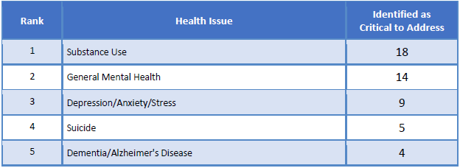

#### Substance Use

**Contributors to Progress**

Those identifying this as a critical issue were asked: “What is contributing to progress on this issue in your community?”

*Awareness/Education*

* Substance abuse education through community organizations. – Other Health Provider (Rutherford County)
* The work of many sectors to address substance use is a positive factor in this effort. The awareness generated by the national media re: the opioid epidemic is also drawing attention to this issue. To be clear, we have a substance abuse problem; not just an opioid problem. But the community readiness to address the problems and engage in prevention and harm reduction activities is most beneficial. – Community Leader (Rutherford County)
* More information and community understanding that substance use disorders (SUD) are chronic health issues, vs. "lack of strength/morals". Committed group of community partners in developing treatment/support programs. Access to treatment for SUD. – Other Health Provider (Rutherford County)
* Educating. – Community Leader (Rutherford County)

*Collaborative Efforts*

* Organizations are collaborating and educating the public on the long-term effects of substance use and abuse. – Other Health Provider (Rutherford County)
* Collaborative efforts. – Other Health Provider (Rutherford County)

*Specific Agencies/Programs*

* Two programs. Our jail release program that is working with addicts beyond their jail time with counseling and support. Our school system recognizing the need to be supportive toward the student with the addiction and confidentially working with them. – Community Leader (Rutherford County)
* There is a lot of energy around this issue locally and nationally, and that’s helpful. Our United Way has been the convener of an energized group of citizens that are looking closely at this issue. We have medicine drop boxes and other specific strategies that are making an impact. – Community Leader (Rutherford County)
* Joining Partners, and suboxone more available. – Other Health Provider (Rutherford County)
* I believe addicts can receive Narcan for free at the health department. Do the addicts know this. – Other Health Provider (Rutherford County)
* Narcan available. – Other Health Provider (Rutherford County)

*Effective Law Enforcement*

* Excellent sheriff's department and municipal police departments. – Other Health Provider (Rutherford County)

*Community Focus*

* Community engagement team is doing excellent work. Drug-free communities work. – Other Health Provider (Rutherford County)
* Effective substance abuse community engagement team. – Community Leader (Rutherford County)

*Laws/Policies*

* Government involvement is helping some, but a long way to go. – Community Leader (Rutherford County)

**Impediments of Progress**

Those identifying this as a critical issue were asked: “What is getting in the way of progress on this issue in your community?”

*Access to Care/Services*

* No substance abuse resources. Substance abusers claim they are suicidal when arrested and go to the hospital versus going to jail. – Physician (Rutherford County)
* Lack of enough services and providers. Ending up in jail or committed to hospital. – Other Health Provider (Rutherford County)

*Funding*

* Lack of funding for uninsured. – Other Health Provider (Rutherford County)

*Availability of Substances*

* The ease of access to prescription painkillers and the history of their overuse. The continued abuse with illegal drugs. – Other Health Provider (Rutherford County)
* Too many “pockets” in the community where street drugs are accessible and the fact that the ED hands people-controlled substances without checking patient history or conversing with the PCP. – Physician (Rutherford County)
* Easy access to drugs. – Community Leader (Rutherford County)

*Denial/Stigma*

* We still have stigma surrounding addiction. Many still view it as a moral failure vs. a disease, and that can hamper efforts. We also need more treatment and resources; particularly on the recovery end of the spectrum. We need safe housing for people who are in treatment or post-treatment and need somewhere safe to stay and maintain their recovery. They wind up back in the same environment and that is detrimental to maintaining recovery. – Community Leader (Rutherford County)
* Stigma associated with getting treatment, difficulty in funding long-term residential programs, housing/jobs post Recovery, or for folks with criminal records. Lack of state funding for treatment for people with no insurance. – Other Health Provider (Rutherford County)

*Awareness/Education*

* Poor economy leads to meth labs. Low value placed on education. – Other Health Provider (Rutherford County)
* Lack of information perhaps. Embarrassment in asking for help. – Other Health Provider (Rutherford County)
* Need more education for abusers and their families of what the effects of abuse are and what help is available to assist them. – Community Leader (Rutherford County)

*Law Enforcement*

* Judicial system. – Other Health Provider (Rutherford County)

*Affordable Care/Services*

* Costs. – Other Health Provider (Rutherford County)

*Unemployment*

* Low income jobs and people not willing to work for money. – Community Leader (Rutherford County)

*Poverty*

* Poverty, lack of education, the power of opioid addiction. – Community Leader (Rutherford County)

*Youth*

* Peer pressure will keep some students from seeking help and low self-esteem will send former inmates back to drug use. – Community Leader (Rutherford County)

#### General Mental Health

**Contributors to Progress**

Those identifying this as a critical issue were asked: “What is contributing to progress on this issue in your community?”

*Awareness/Education*

* North Carolina Department of Public Instruction includes curriculum about healthy relationships, coping skills, decision making, healthy communications. If this curriculum were given priority, the next generation would have better mental health. – Other Health Provider (Rutherford County)
* Working on educating people about where to go for mental health issues. – Community Leader (Rutherford County)

*Specific Agencies/Programs*

* […] Joining Partners is a positive step. – Other Health Provider (Rutherford County)
* We have mental health kiosks that are attempting to identify the population at risk. There is more public awareness due to several of the programs being discussed in open forums. Professional training for law enforcement. – Other Health Provider (Rutherford County)
* An extensive effort by many groups assisting with treatment in the drug crisis will raise the victim's self-esteem and create an environment of care not judgment. – Community Leader (Rutherford County)

*Collaborative Efforts*

* Agencies working together to address issue. – Community Leader (Rutherford County)

*Nothing/No Progress*

* Very little progress is being made in this area. We have very limited choices in providers and [I am not confident in] the quality of the practices we have. I know this firsthand because I have a close family member that has tried to navigate through this system. – Community Leader (Rutherford County)

*Funding*

* Mental health funding for professional organizations and education. – Other Health Provider (Rutherford County)

**Impediments of Progress**

Those identifying this as a critical issue were asked: “What is getting in the way of progress on this issue in your community?”

*Access to Care/Services*

* Too many people go to jail or are involuntarily committed, which shows there are not services or current providers aren't doing their job. – Other Health Provider (Rutherford County)
* Need more mental health available to citizens of county and more long-term care for these patients. – Community Leader (Rutherford County)
* The local emergency department handing out narcotic/controlled substances. – Physician (Rutherford County)
* No real community resources. – Other Health Provider (Rutherford County)

*Lack of Providers*

* Very little progress is being made in this area. We have very limited choices in providers and [I question] the quality of the practices we have. I know this firsthand because I have a close family member that has tried to navigate through this system. – Community Leader (Rutherford County)
* Lack of licensed mental health professionals and affordable mental health care. – Community Leader (Rutherford County)

*Affordable Care/Insurance Issues*

* Cost of everything allows people to make poor choices. Children having babies and not willing to raise them with respect and discipline, rules and guidelines. – Community Leader (Rutherford County)

*Awareness/Education*

* The public image of what mental health is. Understanding it is something that we all deal with on a daily basis. We have to be aware of our surrounding and act appropriately on the keys we see and hear and not ignore signs and symptoms expecting someone else to address. – Other Health Provider (Rutherford County)

*Lack of Collaboration*

* Lack of team effort from all community resources and health professionals. Lack of resources and funding to provide adequate ongoing care. Professionals and care teams are overwhelmed and eventually burn out. High overturn in professional teams due to lack of support and funding. Additional resources need to be provided in the community schools. Additional resources and education for youth from all organizations. – Other Health Provider (Rutherford County)

*Lack Vision/Strategic Planning*

* Lack of patience, realizing there is no quick fix, and staying the course to care. – Community Leader (Rutherford County)
* Lack of Prevention in Schools
* Many health and PE teachers in middle school and high school do not teach the healthful living curriculum with sufficient frequency, professionalism, or enthusiasm. A lost opportunity. – Other Health Provider (Rutherford County)

#### Depression, Anxiety, and Stress

**Contributors to Progress**

Those identifying this as a critical issue were asked: “What is contributing to progress on this issue in your community?”

*Awareness/Education*

* More widespread recognition that depression/anxiety are chronic health issues that can be treated. Community-based providers and doctors who treat depression/anxiety. – Other Health Provider (Rutherford County)
* Increase in public awareness forums. – Other Health Provider (Rutherford County)
* Educating where to find the help. – Community Leader (Rutherford County)

*Nothing/No Progress*

* Very little progress is being made in this area. We have very limited choices in providers and [I am not confident in] the quality of the practices we have. I know this firsthand because I have a close family member that has tried to navigate through this system. – Community Leader (Rutherford County)

*Specific Agencies/Programs*

* […] Joining Partners network. – Other Health Provider (Rutherford County)

*Collaborative Efforts*

* The willingness of cross sector collaboration to address mental health issues. – Community Leader (Rutherford County)

**Impediments of Progress**

Those identifying this as a critical issue were asked: “What is getting in the way of progress on this issue in your community?”

*Access to Care/Services*

* Once again, mismanaged people. And a lack of resources. – Physician (Rutherford County)

*Denial/Stigma*

* There is still stigma attached to mental health disorders, so people do not seek treatment. Can be challenging for people with no insurance to access needed treatment/medications. – Other Health Provider (Rutherford County)
* Stigma. People are still afraid to discuss mental illness for fear of being labeled. – Community Leader (Rutherford County)
* People not getting into services until they are in crisis. Lack of providers. Stigma. – Other Health Provider (Rutherford County)

*Awareness/Education*

* The lack of daily awareness of what our own mental health status is. – Other Health Provider (Rutherford County)

*Lack of Providers*

* Very little progress is being made in this area. We have very limited choices in providers and [I am not confident in] the quality of the practices we have. I know this firsthand because I have a close family member that has tried to navigate through this system. – Community Leader (Rutherford County)

*Diagnosis/Treatment*

* Not getting the right help or asking for help. A lot of children being bullied and picked on... Parents not discipling children or showing they care. – Community Leader (Rutherford County)

#### Suicide

**Contributors to Progress**

Those identifying this as a critical issue were asked: “What is contributing to progress on this issue in your community?”

*Awareness/Education*

* Avaya offers suicide prevention education. RHA Prevention Services Developmental Assets Program (should be required of all). – Other Health Provider (Rutherford County)
* The willingness of various entities to host educational trainings about suicide. The availability of mobile crisis. But we still have a lot of work to do. – Community Leader (Rutherford County)

**Impediments of Progress**

Those identifying this as a critical issue were asked: “What is getting in the way of progress on this issue in your community?”

*Awareness/Education*

* We need to focus more attention on teaching children and youth coping skills, life skills. This should be a major focus in the schools. Reorder priorities of learning. – Other Health Provider (Rutherford County)

*Denial/Stigma*

* Stigma and fear about discussing mental illness. – Community Leader (Rutherford County)

*Access to Care/Services*

* Very few resources for patients. They get brought to the hospital, where they wait in the ER, versus having a crisis center who could better deal with the issue. – Physician (Rutherford County)

#### Dementia and Alzheimer’s Disease

**Contributors to Progress**

Those identifying this as a critical issue were asked: “What is contributing to progress on this issue in your community?”

*Awareness/Education*

* More community understanding of the conditions. Earlier identification of Alzheimer's/dementia in individuals. Proactive Aging Department programs, and general supports/treatment available to both impacted individuals, but caregivers as well. – Other Health Provider (Rutherford County)

*Support Systems for Patients/Caregivers*

* There are resources for caregivers through the Area Agency on Aging and Madison Community Support groups. – Other Health Provider (Rutherford County)

**Impediments of Progress**

Those identifying this as a critical issue were asked: “What is getting in the way of progress on this issue in your community?”

*Family/Caregiver Support*

* Need more consistent training and support for caregiver staff in facilities/individual homes. Lack of treatment that "cures" these diseases...difficulty in stopping progression. – Other Health Provider (Rutherford County)
* Caregiver support through education and resources. – Other Health Provider (Rutherford County)
* Having enough support groups. – Other Health Provider (Rutherford County)

### Social Determinants of Health

Ranking of Social Determinants of Health as Critical to Address

Key informants in the online survey were given a list of conditions in which people are born, grow, live, work, and age, as well as known factors that contribute to a person’s health. They were then asked to select up to three health issues or behaviors that are the most critical to address collaboratively in their community over the next three years or more.

The following chart outlines the rank order of social determinants of health identified by key informants as critical to address.

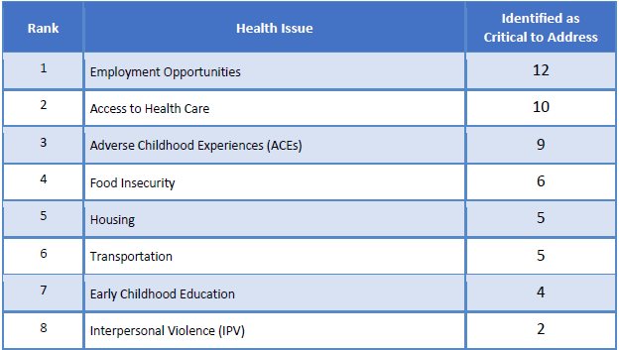

#### Employment Opportunities

**Contributors to Progress**

Those identifying this as a critical issue were asked: “What is contributing to progress on this issue in your community?”

*Economic Development*

* The continued growth in our county makes job opportunities more plentiful than ever before. Our community college is certainly providing new programs in training for 21st century jobs. – Community Leader (Rutherford County)
* The county actively courting companies and offering fiscal advantages for locating here. – Other Health Provider (Rutherford County)
* New businesses opening up in need of employment. – Community Leader (Rutherford County)
* Improving economic conditions, cross-sector collaboration, and opportunities for ongoing education or job retraining. – Community Leader (Rutherford County)
* Economic development continues to work on bringing in new employment opportunities for the residents of the county. – Other Health Provider (Rutherford County)

*Specific Agencies/Programs*

* We have the EDC and Chamber that are working diligently to bring more jobs to the area. – Community Leader (Rutherford County)

*Government/Policies*

* Rutherford government is actively recruiting new industries. County working to diversify economy. – Other Health Provider (Rutherford County)

**Impediments of Progress**

Those identifying this as a critical issue were asked: “What is getting in the way of progress on this issue in your community?”

*Low Wages*

* We need more jobs that pay a livable wage. – Community Leader (Rutherford County)
* Many jobs are minimum wage/little to no insurance or seasonal. Workforce is not fully trained for higher skilled jobs - apathy for people who have been under/unemployed.
* Competition with other counties for clean/high tech industries. – Other Health Provider (Rutherford County)

*Unwillingness to Work*

* Lazy people wanting to live off the government. – Community Leader (Rutherford County)

*Limited Infrastructure*

* Limited infrastructure...county is somewhat isolated...no interstate runs through the area which limits the type of industry that wants to come here. – Community Leader (Rutherford County)

*Alcohol/Drug Abuse*

* Drug use and the vast entitlement programs available that have over time destroyed the work ethic. Some are not qualified to assume the skill level required in 21st century manufacturing but there is a flip side. It is that we have jobs available; many just don't want to work. – Community Leader (Rutherford County)
* Substance use and abuse. Lack of prepared work force. – Other Health Provider (Rutherford County)

*Funding*

* Lack of funding for school system. You have a good school system; you can attract educated workers... – Other Health Provider (Rutherford County)

#### Access to Health Care Services

**Contributors to Progress**

Those identifying this as a critical issue were asked: “What is contributing to progress on this issue in your community?”

*Many Resources*

* The health system in the county is actively engaged in providing a wider array of health/behavioral health treatment. County has FQHC, health department and behavioral health provider offering care to indigent populations. Rutherford Health Council works actively to enhance access to cancer services. – Other Health Provider (Rutherford County)

*Collaborative Efforts*

* […] Joining Partners. – Other Health Provider (Rutherford County)

*Affordable Care/Services*

* Health care opportunities for the low-income population. Additional specialists traveling into the community. – Other Health Provider (Rutherford County)
* Community Health Clinic provides a sliding scale to assist the individuals that may not qualify for care otherwise. – Other Health Provider (Rutherford County)

*Insurance Issues*

* Doctors who take Medicare and Medicaid. – Other Health Provider (Rutherford County)

**Impediments of Progress**

Those identifying this as a critical issue were asked: “What is getting in the way of progress on this issue in your community?”

*Insurance/Medicaid Issues*

* Insurance companies, consistent overbilling on pretty much any medical related procedure/test. – Other Health Provider (Rutherford County)

*Transportation*

* Transportation to services. – Other Health Provider (Rutherford County)

*Access to Care/Services*

* VAYA. – Other Health Provider (Rutherford County)

*Lack of Providers*

* Health care professionals that have retired or left the community and have not been replaced. – Other Health Provider (Rutherford County)
* Difficulty in recruiting and maintaining primary and specialty care providers. Cost of health care and medications for people with no/poor insurance. – Other Health Provider (Rutherford County)

*Awareness/Education*

* The education of where and when to seek care before issues become a crisis situation. – Other Health Provider (Rutherford County)

*Access for Uninsured/Underinsured*

* Poor access to mental health care for the poor. – Other Health Provider (Rutherford County)

*Adverse Childhood Experiences (ACEs)*

**Contributors to Progress**

Those identifying this as a critical issue were asked: “What is contributing to progress on this issue in your community?”

*Awareness/Education*

* Treatment based on adverse childhood trauma by providers, training of agency/school staff on recognizing children, More understating on the health/behavioral health impact of trauma. – Other Health Provider (Rutherford County)
* Growing awareness of the impacts of trauma on brain development and the emotional well-being of children. – Community Leader (Rutherford County)
* We are just beginning to see progress in this area with the showing of the film "Resilience". – Community Leader (Rutherford County)
* More awareness of impact of ACE. – Community Leader (Rutherford County)

*Specific Agencies/Programs*

* Head Start and the Partnership for Children. – Other Health Provider (Rutherford County)

*Recognition Of The Problem*

* Recognition. – Other Health Provider (Rutherford County)

**Impediments of Progress**

Those identifying this as a critical issue were asked: “What is getting in the way of progress on this issue in your community?”

*Awareness/Education*

* Need to continue raising awareness; not enough people know about or understand this connection between adverse childhood experiences and health outcomes in adulthood. – Community Leader (Rutherford County)
* Lack of knowledge about Adverse Childhood Experiences and how it affects health. – Community Leader (Rutherford County)
* No educational resources. – Other Health Provider (Rutherford County)

*Funding*

* Funding and lack of political will to make early childhood a priority. – Other Health Provider (Rutherford County)

*Access to Care/Services*

* Lack of professional counseling; lack of parents' motivation to change parenting behaviors. – Community Leader (Rutherford County)

*Breaking The Cycle of Trauma*

* Difficulty in breaking the cycle of trauma; many children are now experiencing the impact of family trauma. Need to continue training for community members regarding identification and impact of trauma. – Other Health Provider (Rutherford County)

#### Food Insecurity

**Contributors to Progress**

Those identifying this as a critical issue were asked: “What is contributing to progress on this issue in your community?”

*Specific Agencies/Programs*

* Our back program is treating the immediate hunger, but not able to address the cause. – Community Leader (Rutherford County) Farmer's Market. SNAP benefits. – Other Health Provider (Rutherford County)
* Several agencies (e.g., RCI Legacy and Religious Based charities) contribute to various food charities. The Back-Pac program and the "Welcome Table" are prime examples. – Other Health Provider (Rutherford County)

*Food Banks/Pantry*

* Community food banks, food committees and organizations. Churches. Meals on Wheels program. Senior Center. Free or low-cost transportation. – Other Health Provider (Rutherford County)
* Food network, Tailgate Market, WIC program, McKinney Vento Act., backpack program, church food pantries and meal sites. – Other Health Provider (Rutherford County)

*Community Focus*

* Formed food council to address issues of food insecurity. – Community Leader (Rutherford County)

**Impediments of Progress**

Those identifying this as a critical issue were asked: “What is getting in the way of progress on this issue in your community?”

*Awareness/Education*

* Lack of education about the long-term benefits of organic food and soil. Lack of education about eating whole foods. Locally grown food is expensive to grow and expensive to purchase. – Other Health Provider (Rutherford County)
* Community awareness and education. Additional funding. – Other Health Provider (Rutherford County)
* Ignorance. Laziness. Time constraints. – Other Health Provider (Rutherford County)
* Don't fully understand the barriers. – Community Leader (Rutherford County)

*Employment*

* Being able to convince people to go back to work and regain their self-worth and ability to make a contribution to their family. – Community Leader (Rutherford County)

*Government/Policies*

* More of the above, with add-in from government agencies. – Other Health Provider (Rutherford County)

#### Housing

**Contributors to Progress**

Those identifying this as a critical issue were asked: “What is contributing to progress on this issue in your community?”

*Specific Agencies/Programs*

* Pisgah Legal Services is relaunching a Housing Alliance, work is being done around reentry/recovery populations, and the county commissioners have expressed concern about housing issues. – Community Leader (Rutherford County)

*Recognition Of The Problem*

* We have identified that we have a homeless problem. Recognizing that you have a problem is a first step. – Community Leader (Rutherford County)

*Collaborative Efforts*

* Collaborative endeavors. – Other Health Provider (Rutherford County)

*Impediments of Progress*

* Those identifying this as a critical issue were asked: “What is getting in the way of progress on this issue in your community?”

*Affordable Housing*

* Need more low-income housing; many jobs don't necessarily pay enough to meet rent and other bills. – Community Leader (Rutherford County)

*Funding*

* Lack of funding. – Other Health Provider (Rutherford County)

*Unwillingness to Work*

* An unwillingness to work. The attitude that the government has to take care of you. – Community Leader (Rutherford County)

#### Transportation

**Contributors to Progress**

Those identifying this as a critical issue were asked: “What is contributing to progress on this issue in your community?”

*Nothing/No Progress*

* Nothing. – Other Health Provider (Rutherford County)

*Funding*

* Funding for free or low-cost transportation. The addition of sidewalks and walking trails. – Other Health Provider (Rutherford County)

**Impediments of Progress**

Those identifying this as a critical issue were asked: “What is getting in the way of progress on this issue in your community?”

*Funding*

* Additional funding. Community awareness. – Other Health Provider (Rutherford County)
* Funding. – Other Health Provider (Rutherford County)

*Access to Transportation*

* Lack of resources and transit is essentially unavailable to uninsured. – Physician (Rutherford County)

#### Early Childhood Education

**Contributors to Progress**

Those identifying this as a critical issue were asked: “What is contributing to progress on this issue in your community?”

*Specific Agencies/Programs*

* Partnership for children, schools, Head Start. – Other Health Provider (Rutherford County)

*Awareness/Education*

* There are programs active in the community focused on early childhood education. These include the school system and the most recent program Kinderpalooza. – Other Health Provider (Rutherford County)

*School Programs*

* A strong school system with high quality Pre-K, Head Start, and other initiatives, and a Partnership for Children that works closely with licensed child care to make it higher in quality. – Community Leader (Rutherford County)

**Impediments of Progress**

Those identifying this as a critical issue were asked: “What is getting in the way of progress on this issue in your community?”

*Funding*

* Many child care centers are going out of business because we have limited child care subsidy funds and over 250 children on the waiting list for child care placement. – Community Leader (Rutherford County)

*Access to Care/Services*

* Public use of the resources and understanding the importance of giving their children access to these programs. – Other Health Provider (Rutherford County)

#### Interpersonal Violence (IPV)

**Contributors to Progress**

Those identifying this as a critical issue were asked: “What is contributing to progress on this issue in your community?”

* No comments

**Impediments of Progress**

Those identifying this as a critical issue were asked: “What is getting in the way of progress on this issue in your community?”

* No comments

### Other Issues

Ranking of Other Issues as Critical to Address

Key informants in the online survey were given a list of other health conditions not previously addressed in the survey, then asked to select up to three health issues or behaviors that are the most critical to address collaboratively in their community over the next three years or more.

The following chart outlines the rank order of other health conditions identified by key informants as critical to address.

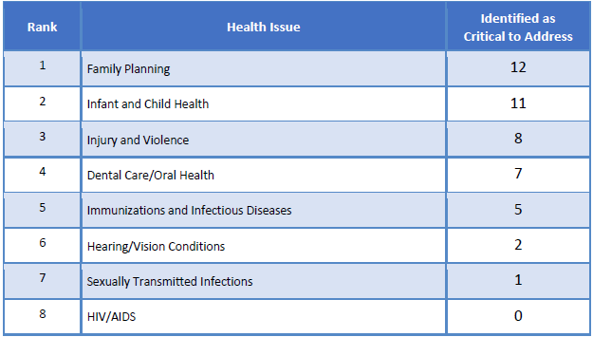

#### Family Planning

**Contributors to Progress**

Those identifying this as a critical issue were asked: “What is contributing to progress on this issue in your community?”

*Health Department*

* The health department, as always, is focused on this area and has done an admirable job. – Community Leader (Rutherford County)
* Health department offers education and interventions/medicines. – Other Health Provider (Rutherford County)
* We have a health department that offers resources to assist in healthy family planning. – Other Health Provider (Rutherford County)
* The health departments offer a variety of contraceptives, I hope. Free. – Other Health Provider (Rutherford County)
* Extensive family planning support at health department. Widespread access to contraceptives. – Other Health Provider (Rutherford County)
* Health department services. – Other Health Provider (Rutherford County)

*Nothing/No Progress*

* Not sure. – Other Health Provider (Rutherford County)

**Impediments of Progress**

Those identifying this as a critical issue were asked: “What is getting in the way of progress on this issue in your community?”

*Cultural/Personal Beliefs*

* [Some communities members who don’t fully understand] access to family planning resources.... – Other Health Provider (Rutherford County)
* There is a large portion of the public do not plan before they start a family. – Other Health Provider (Rutherford County)

*Lack of Prevention in Schools*

* Middle schools and high schools need to teach more anatomy and physiology of the human reproduction system - Better teachers, more often. – Other Health Provider (Rutherford County)

*Denial/Stigma*

* Stigma attached to discussions of sexual behavior and pregnancy in youth. Health education not focused on use of contraception and decision making pre-sexual behavior. Risky behaviors -alcohol/drug use increase unwanted pregnancy. Cost of contraception for indigent care. – Other Health Provider (Rutherford County)

*Poverty*

* Poverty, lack of education, ignorance. – Community Leader (Rutherford County)

*Teen Pregnancy*

* Too many teenagers getting pregnant. – Other Health Provider (Rutherford County)

*Transportation*

* Transportation. – Other Health Provider (Rutherford County)

#### Infant and Child Health

**Contributors to Progress**

Those identifying this as a critical issue were asked: “What is contributing to progress on this issue in your community?”

*Health Department*

* Health department, Blue Ridge Community Clinics, Rutherford Hospital - all offer services and education. – Other Health Provider (Rutherford County)
* Rutherford Polk McDowell Health Department. – Other Health Provider (Rutherford County)
* The health department offers programs that assist new mothers and fathers in proper infant and child health. – Other Health Provider (Rutherford County)
* The health department is doing a good job with perinatal care and nursing programs. – Community Leader (Rutherford County)

*Awareness/Education*

* Education. – Community Leader (Rutherford County)

*Access to Care for Medicaid/Medicare Patients*

* Doctors who take Medicare and Medicaid. – Other Health Provider (Rutherford County)

**Impediments of Progress**

Those identifying this as a critical issue were asked: “What is getting in the way of progress on this issue in your community?”

*Awareness/Education*

* Knowledge of what factors could negatively impact infant and child health. – Other Health Provider (Rutherford County)
* Not enough awareness and transparency about infant and child health. Teach life skills in HS. – Other Health Provider (Rutherford County)

*Funding*

* The low…funds made available by the county commissioners of the three counties. This is especially true of Rutherford County. Other health departments throughout the state contributes much more to their health department. – Other Health Provider (Rutherford County)

*Socioeconomic Factors*

* All of the previous elements affect infant and child health. Poverty, unemployment, and drug addiction. – Community Leader (Rutherford County)

*Nothing*

* Not sure. – Community Leader (Rutherford County)

*Affordable Care/Services*

* Cost, for those who have regular insurance or none at all. – Other Health Provider (Rutherford County)

*Comorbidities*

* Smoking, lack of education, poor prenatal care, poverty and lack of resources. – Community Leader (Rutherford County)

#### Injury and Violence

**Contributors to Progress**

Those identifying this as a critical issue were asked: “What is contributing to progress on this issue in your community?”

*Specific Agencies/Programs*

* Mental health and substance abuse programs. – Other Health Provider (Rutherford County)
* Not entirely sure. I do believe we have a domestic violence problem in the county. I know that Family Resources does provide outreach and education. – Community Leader (Rutherford County)

*School Programs*

* Focus on school safety and methods for reducing impact of gun violence. Programs that provide no-cost car seats and bike helmets. Lighted public walkways/parks. – Other Health Provider (Rutherford County)

*Safety in the Workplace*

* Our manufacturing community is certainly aware of making the workplace safe. – Community Leader (Rutherford County)

**Impediments of Progress**

Those identifying this as a critical issue were asked: “What is getting in the way of progress on this issue in your community?”

*Awareness/Education*

* Knowledge of and use of the programs. Substance abuse. Economic factors such as unemployment. – Other Health Provider (Rutherford County)
* Not sure. Wondering about the younger population and how much they learn about healthy relationships. In addition, the cultural norm right now is all about various forms of violence; such as gun violence. And people are on opposite sides of the spectrum with the gun debates. – Community Leader (Rutherford County)

*Guns Violence*

* Widespread availability of guns, gun culture. Difficulty in gaining families responsible use of bike helmets. – Other Health Provider (Rutherford County)

*Prevalence/Incidence*

* We have become so polarized as a nation that violence erupts in ways that never used to occur. Community leaders have to begin providing leadership that is calming and reasonable. – Community Leader (Rutherford County)

#### Dental Care and Oral Health

**Contributors to Progress**

Those identifying this as a critical issue were asked: “What is contributing to progress on this issue in your community?”

*Dental Bus*

* The dental bus from Rutherford/Polk/McDowell Health Department. – Other Health Provider (Rutherford County)
* Dental bus. Collins Dental Center. – Other Health Provider (Rutherford County)

*Access to Care/Services*

* Our Community Clinic has expanded services to include dental care, our partnership for children is providing preschool dental screenings through a local grant. – Community Leader (Rutherford County)
* Expansion of Rutherford health center dental clinic. – Physician (Rutherford County)

**Impediments of Progress**

Those identifying this as a critical issue were asked: “What is getting in the way of progress on this issue in your community?”

*Poverty*

* No resources for poor. – Other Health Provider (Rutherford County)
* Poverty, Lack of dental insurance, lack of education. – Community Leader (Rutherford County)

*Transportation*

* Transportation and sufficient staff. – Other Health Provider (Rutherford County)

#### Immunizations and Infectious Diseases

**Contributors to Progress**

Those identifying this as a critical issue were asked: “What is contributing to progress on this issue in your community?”

*Awareness/Education*

* Public Education. We still have "decent" schools. – Other Health Provider (Rutherford County)

*Health Department*

* A very comprehensive health department that works diligently with the schools and hospitals to assure that no one lacks treatment or education regarding infectious disease. – Community Leader (Rutherford County)
* Health department services. – Other Health Provider (Rutherford County)

**Impediments of Progress**

Those identifying this as a critical issue were asked: “What is getting in the way of progress on this issue in your community?”

*Cultural/Personal Beliefs*

* […] Anti-vaxxers. – Other Health Provider (Rutherford County)

*Transportation*

* Transportation. – Other Health Provider (Rutherford County)

*Access to Care/Services*

* People not able to access services. – Other Health Provider (Rutherford County)

*Understaffing*

* Not enough staff to do all the work that needs to be done. – Community Leader (Rutherford County)

#### Hearing and Vision Conditions

**Contributors to Progress**

Those identifying this as a critical issue were asked: “What is contributing to progress on this issue in your community?”

*Specific Agencies/Programs*

* Health department giving out birth control and condoms. – Other Health Provider (Rutherford County)

**Impediments of Progress**

Those identifying this as a critical issue were asked: “What is getting in the way of progress on this issue in your community?”

*Affordable Care/Services*

* Cost of hearing aids not covered by insurance and people are not aware of available services from services for the deaf and hard-of-hearing, which is in Partners catchment area. – Other Health Provider (Rutherford County)

#### Sexually Transmitted Infections

**Contributors to Progress**

Those identifying this as a critical issue were asked: “What is contributing to progress on this issue in your community?”

* No comments

**Impediments of Progress**

Those identifying this as a critical issue were asked: “What is getting in the way of progress on this issue in your community?”

* No comments

#### HIV/AIDS

**Contributors to Progress**

Those identifying this as a critical issue were asked: “What is contributing to progress on this issue in your community?”

* No comments

**Impediments of Progress**

Those identifying this as a critical issue were asked: “What is getting in the way of progress on this issue in your community?”

* No comments

### Additional Comments

Other issues uncovered through the online key informant survey include the following:

*Opioid Addiction due to Accessibility*

* Opioid addiction and access to Narcan. – Other Health Provider (Rutherford County)

*Access to Treatment for Mental Illness*

* Residents with mental health and/or substance abuse often end up in jail or being involuntarily committed. This group of people usually are found incapable to proceed to trial and sent to the state hospital. There needs to be somewhere people can go when distressed that is open 24 hours besides the hospital. Preventing a crisis by having choices of providers and some alternatives to get services 24/7 to reduce population in jail and hospitals. – Other Health Provider (Rutherford County)

*Need More Health Care Providers*

* Number of healthcare providers available in the county. Why are we not getting more MDs rather than so many more FNP and PAs. – Other Health Provider (Rutherford County)

*Pollution*

* Water quality, air quality, soil quality. – Other Health Provider (Rutherford County)

# Appendix D – Community Assets and Resources

**Health Resources Inventory**

We conducted an inventory of available resources of our community by reviewing a subset of existing resources currently listed in the 2-1-1 database for our county as well as working with partners to include additional information. Where gaps were identified, we partnered with 2-1-1 to fill in or update this information when applicable.

***Process***

To compile an up to date Health Resource List, Rutherford County CHA partners worked together to review the current 2-1-1 Health Resource List provided by WNC Healthy Impact. Any outdated or incorrect information was edited and saved for future reference. Additions and edits were also sent to the 2-1-1 coordinator so that the 2-1-1 online directory could be updated.

2-1-1 is a health and human service referral line available 24/7 to speakers of many languages. It is free, confidential and can be accessed through the internet (www.nc211.org) or by calling 2-1-1.

***Findings***

During this updating process, much was found in terms of available health resources and supportive services. To begin, RHI Legacy Foundation is a fund-raising and grant making organization focused on improving health and wellness in Rutherford County. RHI Legacy Foundation will offer grants to organizations that increase health and wellness for people in Rutherford County. RHI will pursue, identify, incubate and implement new programs and projects to effectively and efficiently impact the health and wellness of the Rutherford Community. For more information, please follow this link: www.RHILegacyFoundation.com.

Additionally, Rutherford County residents have access to support services including Family Preservation Services, Clara Allen Family Center, Area Agency on Aging, Family Caregiver Support, Mom’s Hope Support Group, Workforce Development, NAMI South Mountains NC, Pisgah Legal Services and much more. There are also several food pantries in the county that assist food insecure families. Further, Rutherford County offers many county services through the Health Department, Animal Shelter, Recreation Department, Department of Social Services and many others.

Lastly, another county strength is Isothermal Community College (ICC) where our residents can earn a GED or achieve higher education. ICC is part of the NC Community College System and they not only provide curriculum courses to earn a degree, diploma, or certificate, but also an abundance of continuing education. Continuing education courses are for people interested in training in different vocations, such as equine studies, hospitality & tourism, professional development, massage therapy, culinary arts and more.

***Resource Gaps***

Though many resources are available, there are gaps that need to be filled so that Rutherford County residents have adequate access to services. The following includes gaps that were identified through reviewing available resources and key stakeholder surveys.

For example, although there are many private fitness centers, there is not a YMCA offering a set of structured programs to promote family physical activity. The YMCA provides programs for vulnerable populations through their Population Health Programs. Many residents feel that a YMCA would benefit Rutherford County’s effort to adopt healthier lifestyles.

Another noted gap is a lack of providers and available resources including treatment for folks suffering from a mental health illness and/or substance abuse.

Additionally, the availability of public transportation for the un-insured has also been identified as a resource gap that affects many different areas of wellbeing. The lack of county-wide public transportation has been listed as an impediment in terms of making it difficult for residents to travel to obtain proper medical care or take part in health programs, commute to and from work or to secure essential items for daily living including nutritious foods and medications.

Finally, the most glaring gap exists in the underfunding of the Public Health System through local governance. The Public Health System plays a critical role as convener of partners and as advisor and implementer of community level programs and policies to enhance community health. However, the Public Health System remains woefully underfunded to perform at optimal levels.

www.NC211.org